

Microsoft Team Foundation Server 2010 Management Pack Guide for System Center Operations Manager 2007 and 2012

Microsoft Corporation

Published: November 2012

Send suggestions and comments about this document to [mpgfeed@microsoft.com](mailto:mpgfeed@microsoft.com?subject=SQL%20Server%20Management%20Pack%20Guide%20Published%20Jan%2008). Please include the management pack guide name with your feedback.

Copyright

Information in this document, including URL and other Internet Web site references, is subject to change without notice. Unless otherwise noted, the companies, organizations, products, domain names, e-mail addresses, logos, people, places, and events depicted in examples herein are fictitious. No association with any real company, organization, product, domain name, e-mail address, logo, person, place, or event is intended or should be inferred. Complying with all applicable copyright laws is the responsibility of the user. Without limiting the rights under copyright, no part of this document may be reproduced, stored in or introduced into a retrieval system, or transmitted in any form or by any means (electronic, mechanical, photocopying, recording, or otherwise), or for any purpose, without the express written permission of Microsoft Corporation.

Microsoft may have patents, patent applications, trademarks, copyrights, or other intellectual property rights covering subject matter in this document. Except as expressly provided in any written license agreement from Microsoft, the furnishing of this document does not give you any license to these patents, trademarks, copyrights, or other intellectual property.

© 2010 Microsoft Corporation. All rights reserved.

Microsoft, MS-DOS, Windows, Windows Server, System Center Operations Manager, Visual Studio, Team Foundation Server, and Active Directory are trademarks of the Microsoft group of companies. All other trademarks are property of their respective owners.

Revision History

| **Release Date** | **Changes** |
| --- | --- |
| September 2010 | Original release of this guide |
| November 2012 | Updated Management Pack and guide released. See “Changes in This Update” for details. |

Contents

Introduction to the Team Foundation Server 2010 Management Pack Guide 6

Document Version 6

Getting the Latest Management Pack and Management Pack Documentation 6

Changes in This Update 6

Supported Configurations 6

Getting Started 7

Import the Management Pack 8

Create a New Management Pack for Customizations 8

Customize the Team Foundation Server 2010 Management Pack 9

Security Considerations 10

Run As Profiles 10

Understanding the Team Foundation Server 2010 Management Pack 11

Discovery Process 11

Objects the Management Pack Discovers 11

Relationships 14

Relationship Class Diagram 15

How Health Rolls Up 15

Health Model 16

Monitors 18

Viewing Information in the Operations Manager Console 18

Diagram Views 19

Console Tasks 22

Agent Tasks 23

Diagnostics and Recoveries 24

Reports 24

Appendix A – Installation on System Center Operations Manager 2007 SP1 30

Pre-Requisites 30

Steps to Install the Management Pack 30

Installing the Team Foundation Server MP 33

Allow the Application Tier Servers Permissions in Operations Manager. 36

Non-Default Port Configuration and SSL Only Bindings 38

View of the Team Foundation Server MP Objects in the Operator Console. 43

Appendix B – Installation on System Center Operations Manager 2007 R2 45

Pre-Requisites 45

Steps to Install the Management Pack 45

Installing the Team Foundation Server MP. 49

Associate the “Run As Account” to the “TFS 2010 User Profile” 50

Allow the Application Tier Servers Permissions in Operations Manager. 57

Non-Default Port Configuration and SSL Only Bindings 59

View of the Team Foundation Server MP Objects in the Operator Console 63

Appendix C - Known Issues and Troubleshooting 65

Troubleshooting Incomplete Discovery 65

Appendix D – Installation and Use of the Team Foundation Server 2010 Best Practices Analyzer 69

## Introduction to the Team Foundation Server 2010 Management Pack Guide

The Team Foundation Server 2010 Management Pack provides both proactive and reactive monitoring of Microsoft Team Foundation Server 2010. It monitors TFS components such as application tier server instances, team project collections, build servers, and proxy servers.

The monitoring provided by this management pack includes availability and configuration monitoring, performance data collection, and default thresholds. You can integrate the monitoring of Team Foundation Server components into your service-oriented monitoring scenarios.

### Document Version

This guide was written based on the 1.0.0.7 Management Pack.

### Getting the Latest Management Pack and Management Pack Documentation

You can find the Team Foundation Server 2010 Management Pack at the System Center Operations Manager Marketplace (<http://go.microsoft.com/fwlink/?LinkId=82105>). The latest version of this document is available at the Microsoft Download Center.

#### Changes in This Update

The Team Foundation Server 2010 Management Pack version 1.0.0.0 is the initial release and was released in September of 2010.

As of November 2012, version 1.0.0.7 is the most recent release of the Team Foundation Server 2010 Management Pack. While it does not contain any new features, it includes an updated EULA and a few notable bug fixes. As a result of these bug fixes, the Management Pack now correctly supports the following:

1. Non-default virtual directories.
2. Build controllers using HTTPS.
3. Cloned Application Tiers in the same domain.

Furthermore, since System Center Operations Manager 2012 is designed to support all 2007 Management Packs, this document has been updated to confirm that the Team Foundation Server 2010 Management Pack is compatible with System Center Operations Manager 2012 as well.

### Supported Configurations

The Team Foundation Server 2010 Management Pack for Operations Manager 2007 and 2012 is designed for the following versions of System Center Operations Manager:

• System Center Operations Manager 2007 SP1

• System Center Operations Manager 2007 R2

* System Center Operations Manager 2012
* System Center Operations Manager 2012 SP1

In general, the supported configurations are outlined in the following locations:

• [Microsoft Support Lifecycle policy](http://go.microsoft.com/fwlink/?LinkId=123820)

• [Operations Manager 2007 SP1 Supported Configurations](http://technet.microsoft.com/en-us/library/dd819933.aspx)

• [Operations Manager 2007 R2 Supported Configurations](http://go.microsoft.com/fwlink/?LinkId=90676)

* [Operations Manager 2012 Supported Configurations](http://technet.microsoft.com/en-US/library/jj656649.aspx)
* [Operations Manager 2012 SP1 Supported Configurations](http://technet.microsoft.com/en-us/library/jj656654.aspx)

The Team Foundation Server 2010 Management Pack for Operations Manager is designed to monitor the versions of Team Foundation Server listed in the following table.

| **Version** | **32-bit OS** | **64-bit OS** |
| --- | --- | --- |
| Team Foundation Server 2010 | Supported | Supported |

### Getting Started

You can use the Team Foundation Server 2010 Management Pack to monitor components of Team Foundation Server 2010 system, including application tier servers, team project collections, build servers, and proxy servers. Once installed the management pack will discover the Team Foundation Server 2010 installations that are installed on SCOM monitored servers. For more information about object discovery, see the [Object Discoveries in Operations Manager 2007](http://go.microsoft.com/fwlink/?LinkId=108505) topic in Operations Manager 2007 Help.

#### Before You Import the Management Pack

As a best practice, you should import the Windows Server Management Pack for the operating system you are using. The Windows Server Management Packs monitor aspects of the operating system that influence the performance of computers running SQL Server, such as disk capacity, disk performance, memory utilization, network adapter utilization, and processor performance.

#### Files in This Management Pack

This release includes:

• One Team Foundation Server 2010 Management Pack

The following table describes the files included in this management pack.

| **File** | **Display name** | **Description** |
| --- | --- | --- |
| TeamFoundationServer2010.mp | Team Foundation Server 2010 Management Pack | Contains the object types, discoveries, and monitoring for Team Foundation Server 2010. |
| EULA.RTF | End User License Agreement | The license for the Team Foundation Server 2010 Management Pack for Systems Center Operations Manager. |

#### Other Requirements

To run the TFS BPA task you must have installed the TFS BPA on the application tier servers. Instructions on this are included in Appendix D – Installation of the Team Foundation Server 2010 Best Practices Analyzer of this document. This can be done after installation of the management pack, or at any time before running the TFS BPA command.

### Import the Management Pack

For general information about importing a management pack, see [How to Import a Management Pack in Operations Manager 2007](http://go.microsoft.com/fwlink/?LinkId=142351).

By default the .MSI installer will place the management pack files in the “%ProgramFiles%\System Center Management Packs/Team Foundation Server 2010 MP” directory unless the install location is modified during the install.

**Note:** If the server where the Management Pack Windows Installation file is installed runs 64 bit Windows, the Management Pack will be installed in the %Program Files(x86)% folder by default.

To start monitoring, import the TeamFoundationServer2010.mp file into System Center Operations Manager. It is highly recommended you follow the detailed installation instructions in: Appendix A – Installation on Systems Center Operations Manager 2007 SP1, or Appendix B – Installation on Systems Center Operations Manager 2007 R2 for the version of System Center Operations Manager you are running. The installation requires a number of setup steps to properly configure the management pack to discovery the TFS installation.

### Create a New Management Pack for Customizations

The Team Foundation Server 2010 Management Pack is sealed so that you cannot change any of the original settings in the management pack file. However, you can create customizations, such as overrides or new monitoring objects, and save them to a different management pack. By default, Operations Manager saves all customizations to the default management pack. As a best practice, you should instead create a separate management pack for each sealed management pack you want to customize.

Creating a new management pack for storing overrides has the following advantages:

• It simplifies the process of exporting customizations that were created in your test and pre-production environments to your production environment. For example, instead of exporting the default management pack that contains customizations from multiple management packs, you can export just the management pack that contains customizations of a single management pack.

• It allows you to delete the original management pack without first needing to delete the default management pack. A management pack that contains customizations is dependent on the original management pack. This dependency requires you to delete the management pack with customizations before you can delete the original management pack. If all of your customizations are saved to the default management pack, you must delete the default management pack before you can delete an original management pack.

• It is easier to track and update customizations to individual management packs.

For more information about sealed and unsealed management packs, see [Management Pack Formats](http://go.microsoft.com/fwlink/?LinkId=108355). For more information about management pack customizations and the default management pack, see [About Management Packs](http://go.microsoft.com/fwlink/?LinkId=108356).

To Create a New Management Pack for Customizations

|  |
| --- |
| 1. Open the Operations console, and then click the Administration button.  2. Right-click Management Packs, and then click Create New Management Pack.  3. Enter a name (for example, TFS2010 Customizations), and then click Next.  4. Click Create. |

### Customize the Team Foundation Server 2010 Management Pack

The following recommendations may help reduce unnecessary alerts or overhead.

• If you are monitoring instances of Team Foundation Server and **do not** have the build servers monitored by System Center Operations Manager, create an override and disable the **TeamFoundationServer2010.ATTierDiscoveryWithBuildSubsystem** discovery. The discovery called **TeamFoundationServer2010.ATTierDiscoveryNoBuildSubsystem** will discover the system without the build servers, so leave this discovery enabled. There is no harm in keeping both enabled, but disabling the extra discovery will reduce overhead.

• If you are monitoring instances of Team Foundation Server and **do** have the build servers monitored by System Center Operations Manager, create an override and disable the **TeamFoundationServer2010.ATTierDiscoveryNoBuildSubsystem** discovery. The other discovery called **TeamFoundationServer2010.ATTierDiscoveryWithBuildSubsystem** will discover the system without the build servers, so leave this discovery enabled. There is no harm in keeping both enabled, but disabling the extra discovery will reduce overhead.

### Security Considerations

Due to the methods used to monitor the Team Foundation Server resources, agentless monitoring is not supported. Also, due to the security model that Team Foundation Server 2010 uses the monitoring account will need to be a member of the *[TEAM FOUNDATION]\Team Foundation Administrators* group. This facilitates the management pack to be able to discover and monitor new Team Project Collections as they are added to the configuration without requiring additional incremental security configuration.

The detailed setup instructions located in Appendix A and Appendix B of this document outline the creation of the required monitoring account as well as required security privileges.

### Run As Profiles

When the Team Foundation Server 2010 Management Pack is first imported, it creates one new Run As profiles:

• TFS 2010 User Profile

This profile is associated with all discoveries, monitors, and tasks.

Configuration of the Run As Profile is covered in Appendix A and Appendix B with details targeted to the version of System Center Operations Manager that is in use.

For more information, see [Run As Profiles and Run As Accounts in Operations Manager 2007](http://go.microsoft.com/fwlink/?LinkId=140793) .

## Understanding the Team Foundation Server 2010 Management Pack

### Discovery Process

Once the installation has been successfully performed and Team Foundation Server MP is loaded, the discovery process can start. At the end of this process which can take up to 15 minutes, various Team Foundation Server objects are created and their properties are set with discovered values. The objects discovered will vary for different Team Foundation Servers based on the installed configuration. Along with the objects, the relationships between these objects are also established.

### Objects the Management Pack Discovers

You can use the Team Foundation Server 2010 Management Pack to monitor components of a Team Foundation Server 2010 installation. The management pack is configured to do automatic discovery of each Team Foundation Server 2010 installation by performing queries against the Team Foundation Server 2010 configuration APIs. For more information about object discovery, see [Object Discoveries in Operations Manager 2007](http://go.microsoft.com/fwlink/?LinkId=108505) in Operations Manager 2007 Help.

The Team Foundation Server 2010 Management Pack discovers the object types described in the following list.

Objects Discovered

TeamFoundationServer2010.TFSInstallation

TeamFoundationServer2010.TFSApplicationTier

TeamFoundationServer2010.TFSAdministrationWebService

TeamFoundationServer2010.TFSAuthorizationWebService

TeamFoundationServer2010.TFSBuildWebService

TeamFoundationServer2010.TFSProjectCollection

TeamFoundationServer2010.TFSRegistrationWebService

TeamFoundationServer2010.TFSVersionControlWebService

TeamFoundationServer2010.TFSWarehouse

TeamFoundationServer2010.TFSWebAccess

TeamFoundationServer2010.TFSWorkItemTrackingWebService

TeamFoundationServer2010.TFSBuildAgent

TeamFoundationServer2010.TFSBuildController

TeamFoundationServer2010.TFSBuildServer

TeamFoundationServer2010.TFSProxy

Relationships Discovered

TeamFoundationServer2010.TFSInstallationContainsATServer

TeamFoundationServer2010.TFSATServerHostsAdministrationWebService

TeamFoundationServer2010.TFSATServerHostsAuthorizationWebService

TeamFoundationServer2010.TFSATServerHostsBuildWebService

TeamFoundationServer2010.TFSATServerHostsRegistrationWebService

TeamFoundationServer2010.TFSATServerHostsVersionControlWebService

TeamFoundationServer2010.TFSATServerHostsWebAccess

TeamFoundationServer2010.TFSATServerHostsWorkItemTrackingWebService

TeamFoundationServer2010.TFSInstallationContainsProjectCollections

TeamFoundationServer2010.TFSInstallationContainsWarehouse

TeamFoundationServer2010.TFSBuildServerHostsBuildAgent

TeamFoundationServer2010.TFSBuildServerHostsBuildController

TeamFoundationServer2010.TFSInstallationContainsBuildServer

TeamFoundationServer2010.TFSProjectCollectionContainsBuildAgent

TeamFoundationServer2010.TFSProjectCollectionContainsBuildController

The following screen shot shows that a TFS2010 installation has been discovered. This view will vary based on the specific local environment where Team Foundation Server MP is used.

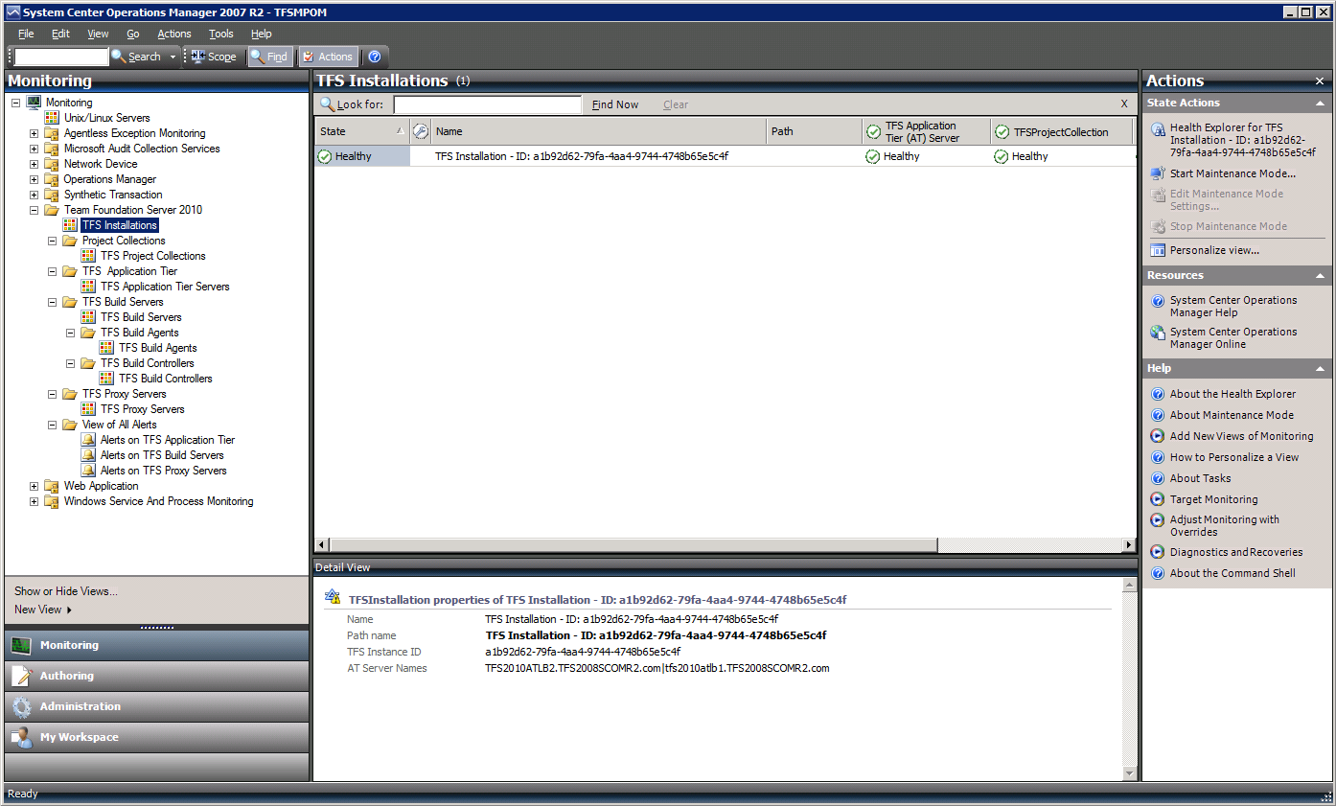

Figure: View of Discovered Objects

Similarly, other Team Foundation Server objects that have been discovered can be navigated to in the left pane and browsed from the Operator Console.

Inheritance Class Diagram

Inheritance Class Diagram



Figure: Inheritance Class Diagram

### Relationships

Hosting relationships are enabled between the classes to provide for roll-up of health status. The Team Foundation Installation object contains Team Project Collections, Application Tier Servers, Build Servers, and Warehouse. The Application Tier Servers contains the web services, and web access portal. The relationships are built to support roll up of status to the Team Foundation Installation level. Each Team Foundation Installation will have a unique identifier (GUID) that is used by TFS2010 to associate all the associated components together. Since a friendly name is not exposed in TFS2010, the installation GUID is exposed as the name of the installation.

### Relationship Class Diagram



Figure: Relationship Class Diagram

### How Health Rolls Up

The Team Foundation Server 2010 Management Pack categorizes the server components into a layered structure, where the health of one layer can depend on the health of the lower level.

#### Top Level

The top level of this model contains the TFS Installation object. If the components of the installation are not healthy, the installation is not healthy.

#### Second Level

|  |  |
| --- | --- |
| The second level contains these components: | **•** Application Tier Servers  **•** Build Servers  **•** Analysis Services (contains no lower-level components)  Note  The health of each of these components directly affects the health of the TFS Installation. |

### Health Model

Health Model is comprised of the dynamic view of the states of various Team Foundation Server objects. Note that the health states of the Team Foundation Server application tier, is a dependent function of the health of its sub-components. There is a dependency relationship in the health model as rollup of health states from the sub-components to the top level node happens.

To view the health model of any entity, right click on the object in the “Details View” in the middle pane and click Open->Health Explorer for that specific object. Or just click on the Health Explorer in the Actions Pane on the right. The health explorer can be launched for the top level object as well as the objects lower in the hierarchy.

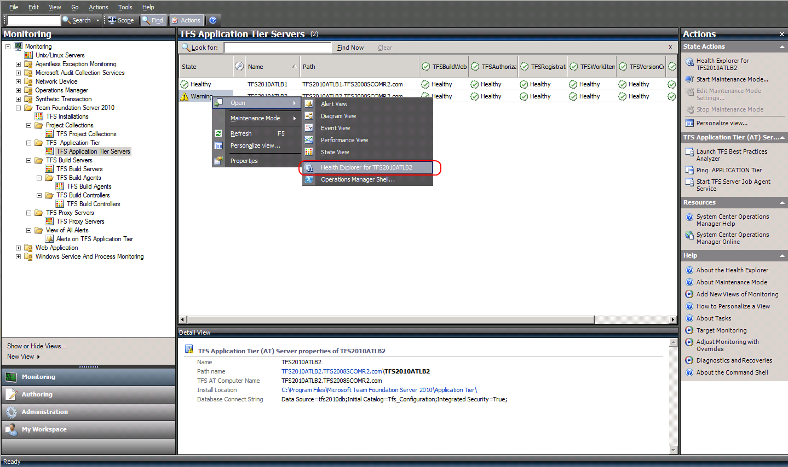

Figure: Health Model View

Once the Health Explorer is launched, its window pops up showing the state of the object and the various monitors of that object arranged in a tree view as shown below.

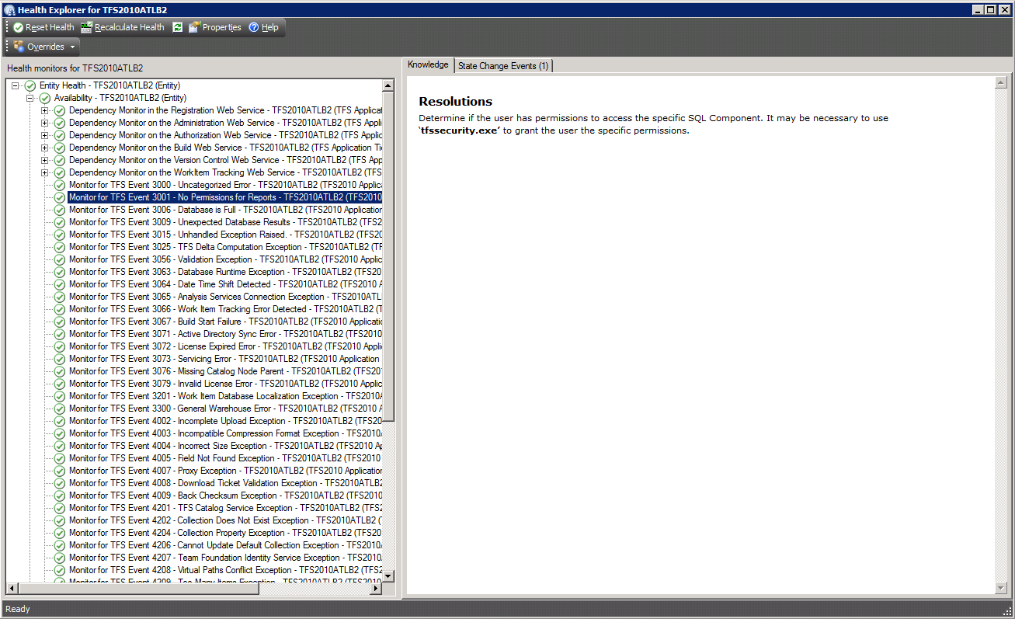

Figure: Health Explorer View

The following is another view of the Health Explorer for an object showing a few unhealthy states (red). Additionally, the possible causes and resolutions are listed on the “Knowledge” article on the right.

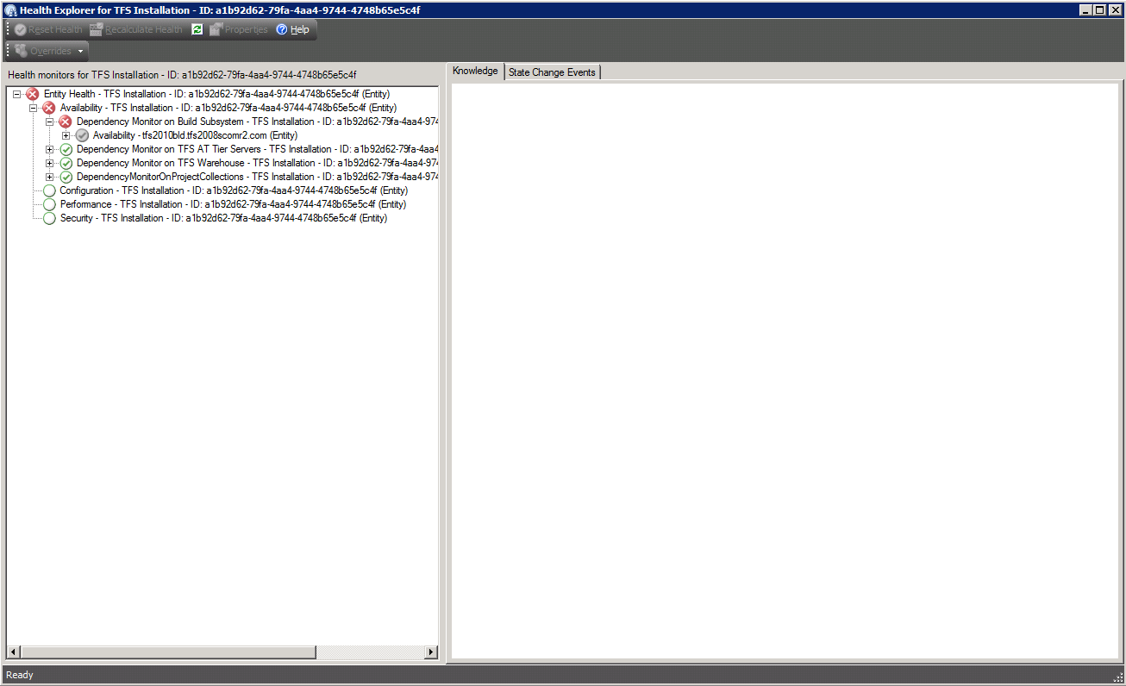

Figure: Health Explorer View with Critical Alerts

As mentioned, the health model is a reflection of the state of the object instance at that point in time and is constantly updated by the various monitors that run in the background. Incidentally, the health model also shows the containment relationships of the service model in the form of the ability to drill down into the contained objects health.

### Monitors

Primarily the monitors are comprised of three types;

* Monitors that watch event log entries
* Script based WebService Monitors which query the various web services for proper response status
* Monitors for key Team Foundation Server 2010 system performance counters

### Viewing Information in the Operations Manager Console

You can see a high-level view of object types in your Team Foundation Server 2010 deployment.

A view can contain a lengthy list of objects. To find a specific object or group of objects, you can use the Scope, Search, and Find buttons on the Operations Manager toolbar. For more information, see the How to Manage Monitoring Data Using Scope, Search, and Find topic in Operations Manager 2007 Help.

### Diagram Views

The relationship between the various objects in the Service Model for Team Foundation Server can also be viewed by using the Diagram View feature of the Operator Console.

The diagram view is accessed by right clicking the object in question and choosing the “Diagram View” menu option as shown below.

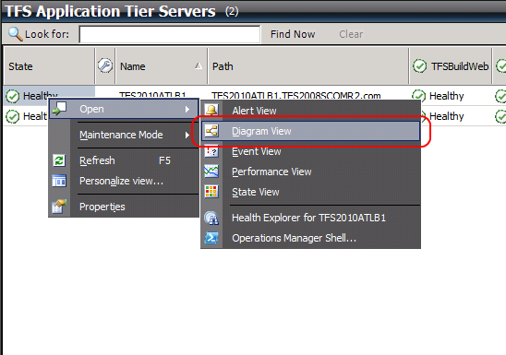

Figure: Opening the Diagram View

Once the basic view shows up, refresh the Diagram View pane and click on the + sign to drill down deeper if required. Sometimes the Diagram view surface is blank and may need to be refreshed.

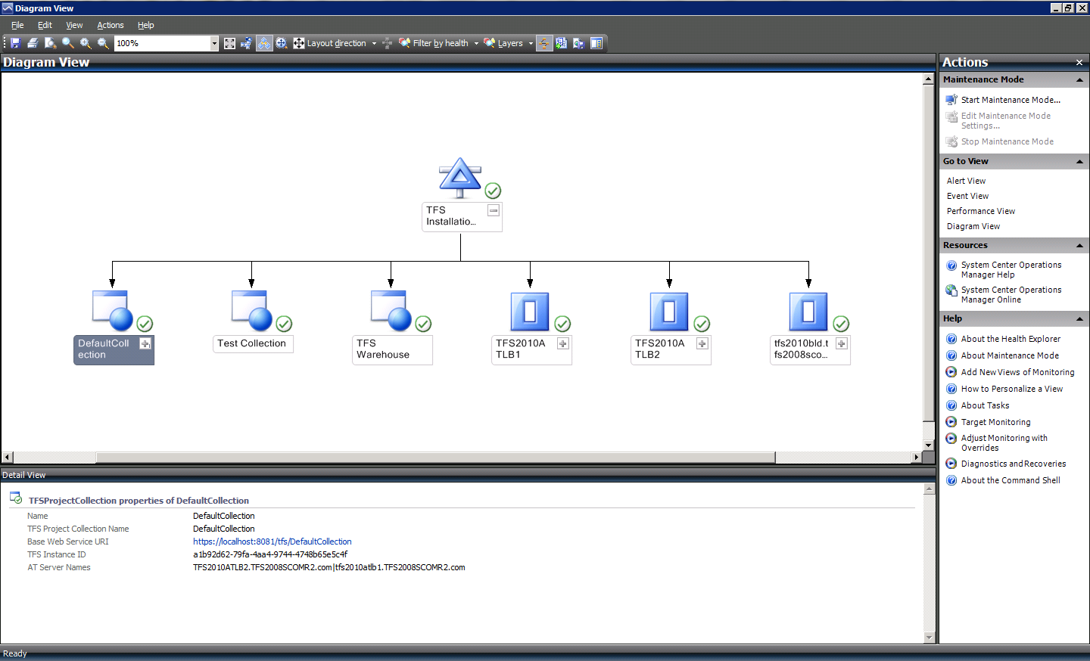

Figure: Diagram View with drill down

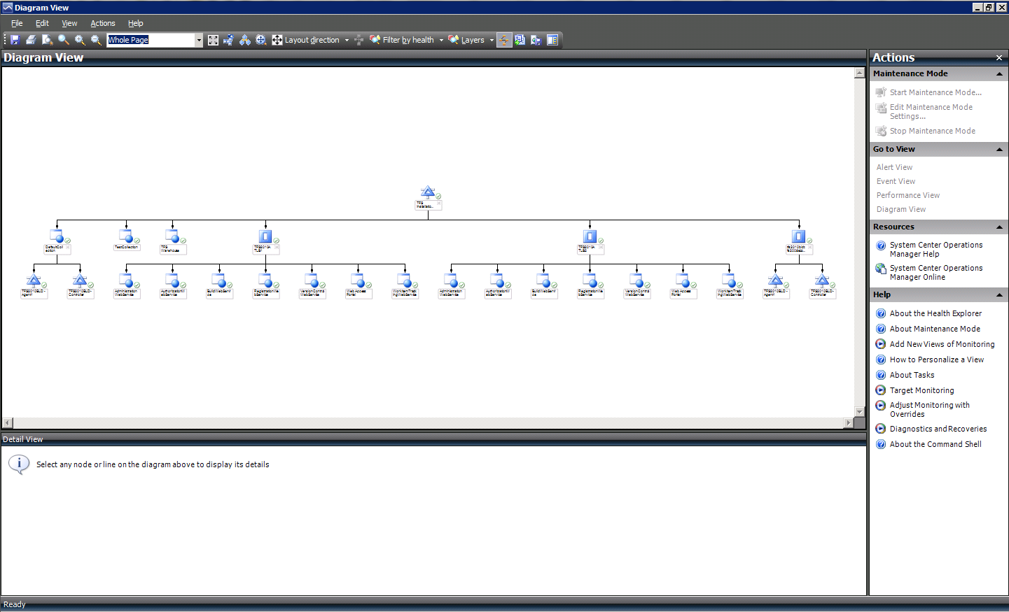

Figure: Diagram View after full drilled down

#### Alert Views

The following Alert Views are defined in the Operator Console.

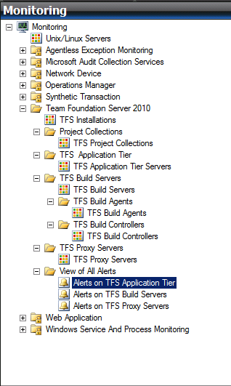

Figure: Alert View node on the Monitoring console.

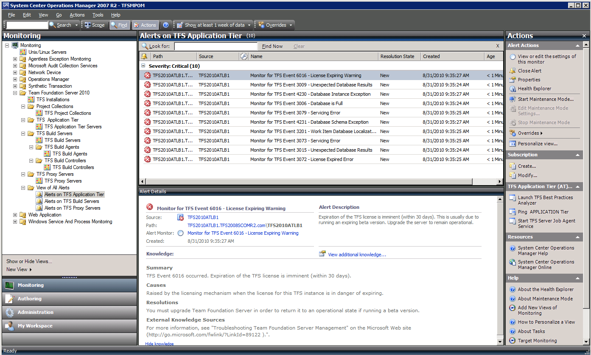

Figure: View of a few Alerts

#### Tasks

There are two types of tasks. Console tasks which execute on the Operator Console host and Agent tasks which execute remotely on the host where the OpsMgr Agents are installed. In case of Team Foundation Server, these will be on the hosts where the application tier is detected. These tasks can be launched by clicking on the task.

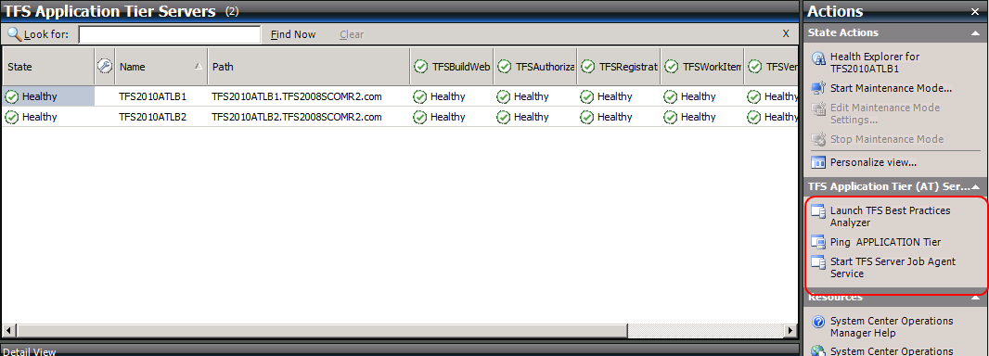

Figure: Launching Tasks

## Console Tasks

1. Ping application tier Machine: Ping the application tier machine and check if it is reachable.
2. Ping Data Tier Machine: Ping the Data Tier machine and check if it is reachable.

The following is the output window when the task “Ping Data Tier” is launched.

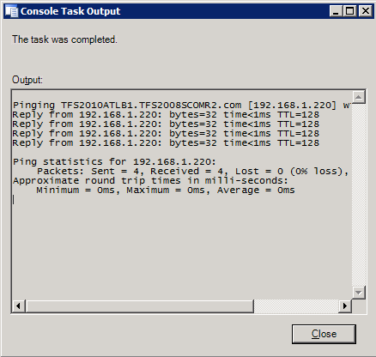

Figure: Output of Console Task “Ping Data Tier”

## Agent Tasks

1. Launch Best Practice Analyzer (BPA) for Team Foundation Server –

To launch BPA for Team Foundation Server, it has to be installed on the default locations on those machines where a Team Foundation Server application tier has been discovered. The following shows the “TFS BPA Launch” dialog box. Clicking on Run will produce an output file by BPA for Team Foundation Server in the default location on the selected machine. To enable this feature, BPA for Team Foundation Server has to be installed in the default location and the output folder must exist. See Appendix D for details of how to install and use the TFS Best Practices Analyzer.

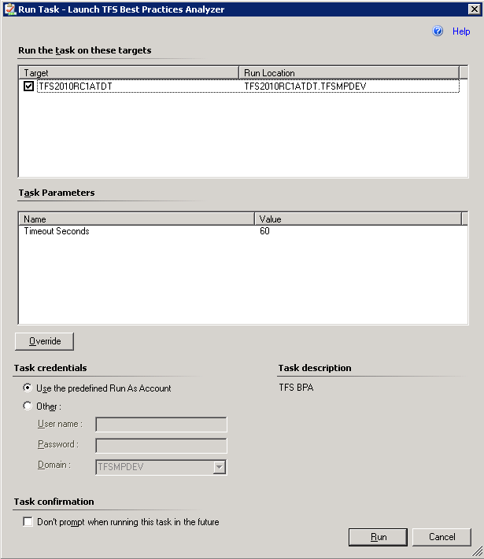

Figure: Dialog of Agent Task “Launch TFS Best Practices Analyzer”

1. Start Team Foundation Server Job Agent Service.
   1. If for some reason Team Foundation Server Job Agent process on the AT is down, this can be used to restart it.

## Diagnostics and Recoveries

There are a few diagnostic and recovery actions included. These are primarily for the “Team Foundation Server Job Agent” and “Team Foundation Server Build Server” services. If any of these services stop, the MP detects this situation and attempts a recovery by initiating a restart of these services.

## Reports

The Team Foundation Server MP leverages the reporting infrastructure of Operations Manager. The following standard reports are delivered with System Center Operations Manager.

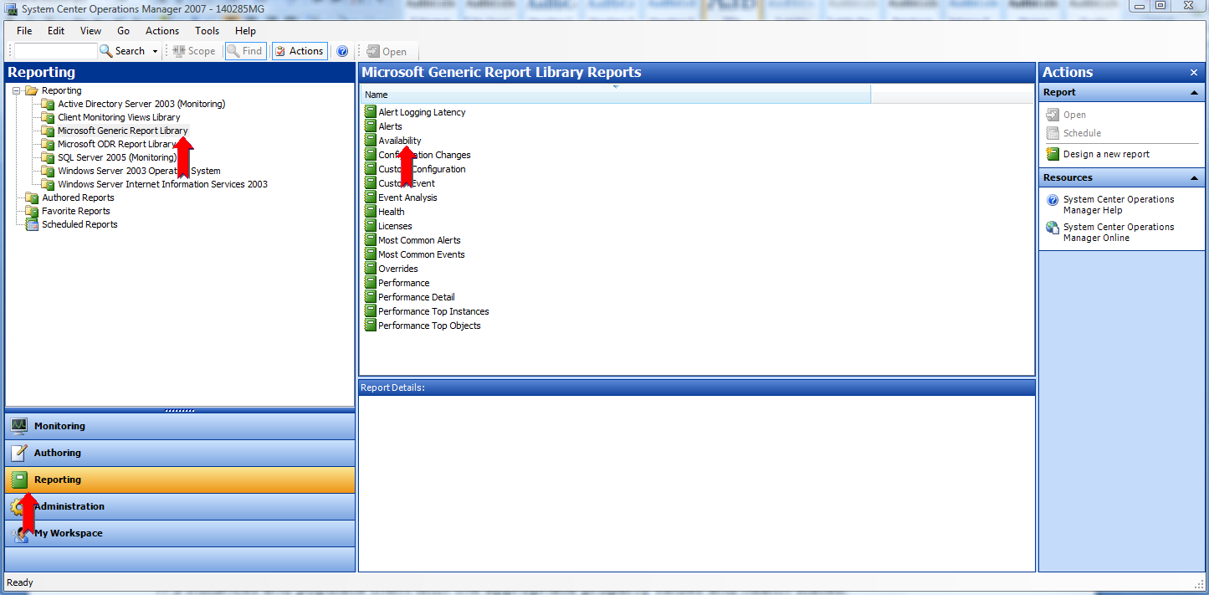Figure: Operation Manager Standard Reports

A few sample reports are shown below.

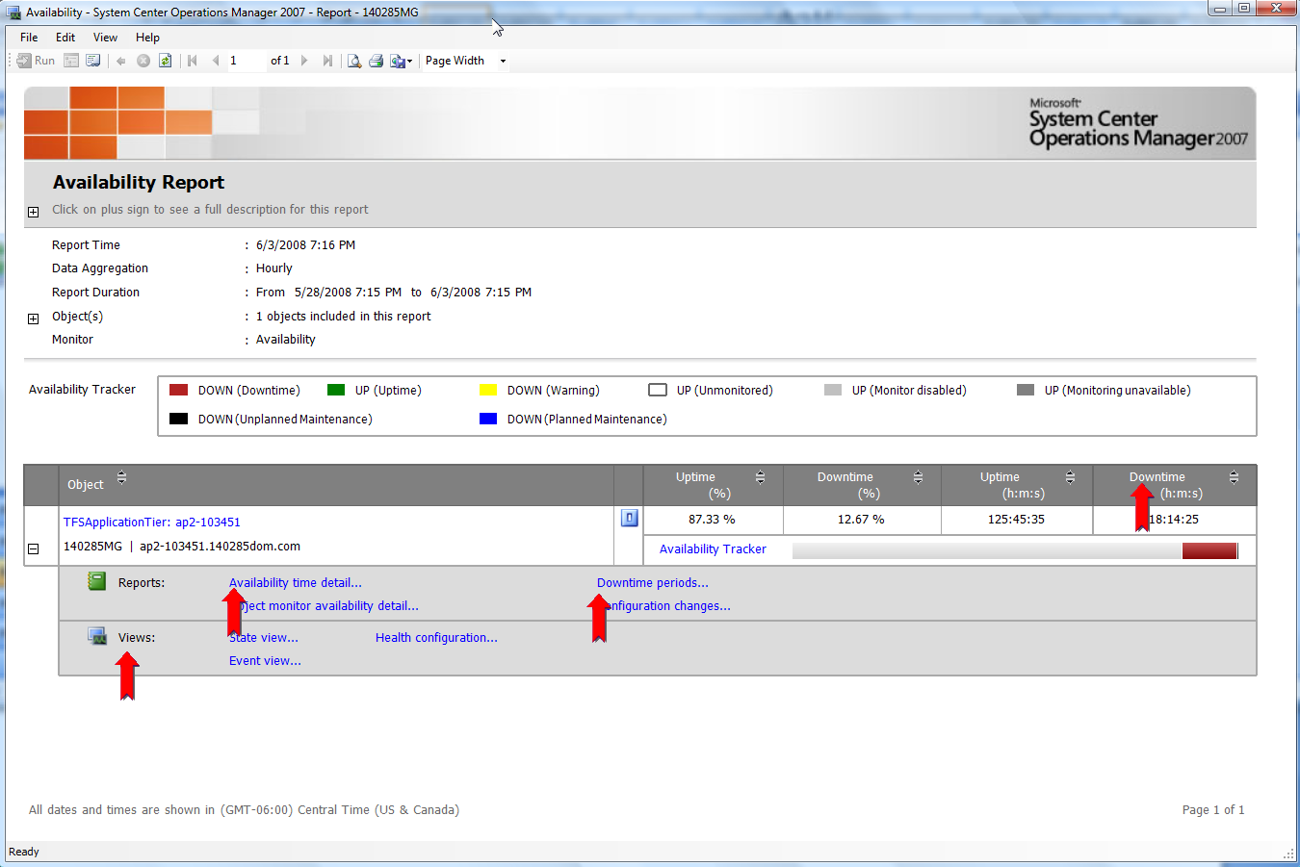

Figure: Availability of Team Foundation Server application tier

The availability report allows drill down detail of downtime. More actions are available by clicking on the actions + plus sign on the report.

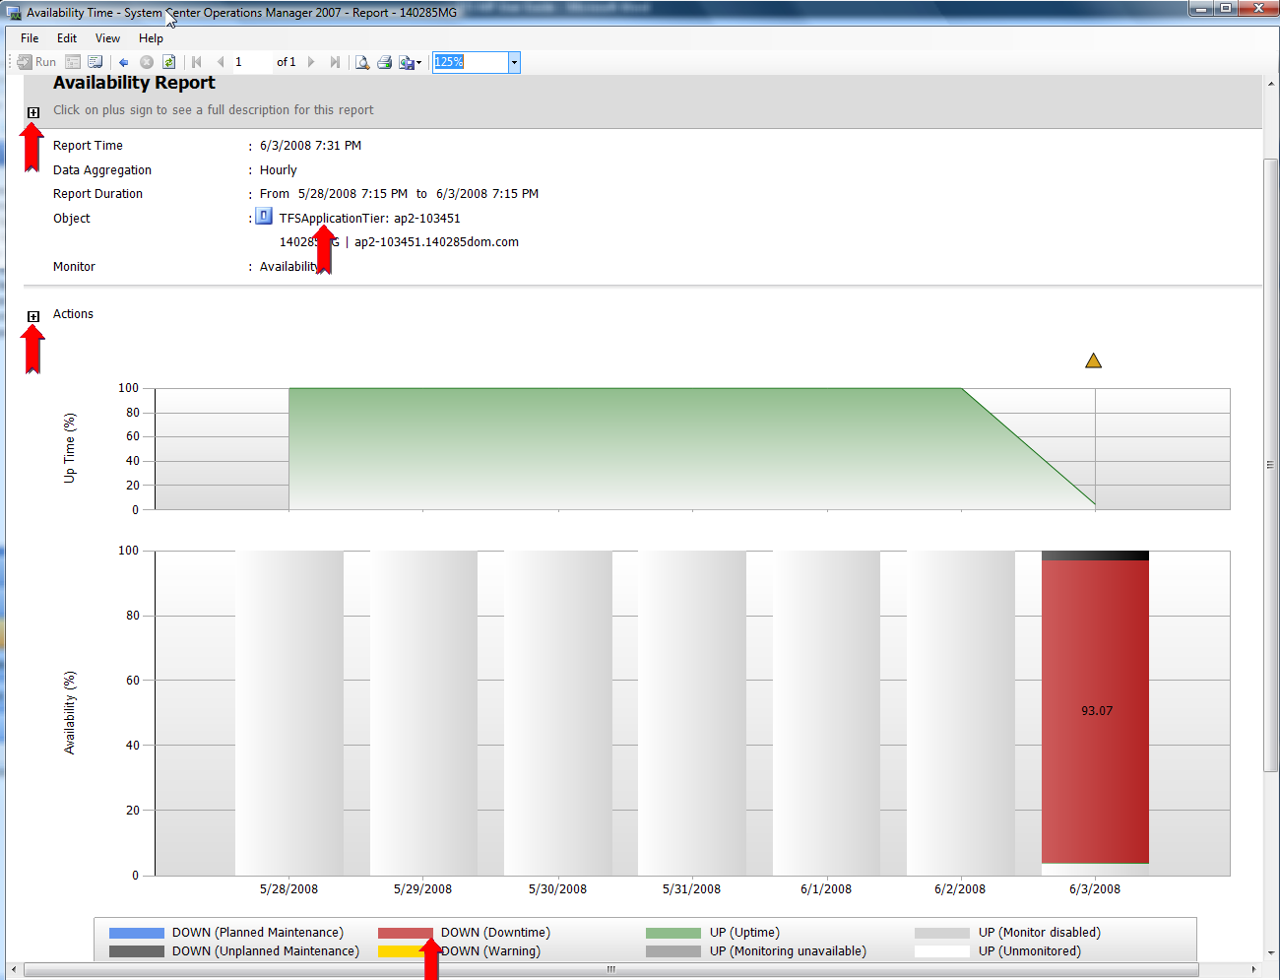

Figure: Drill down into availability time details

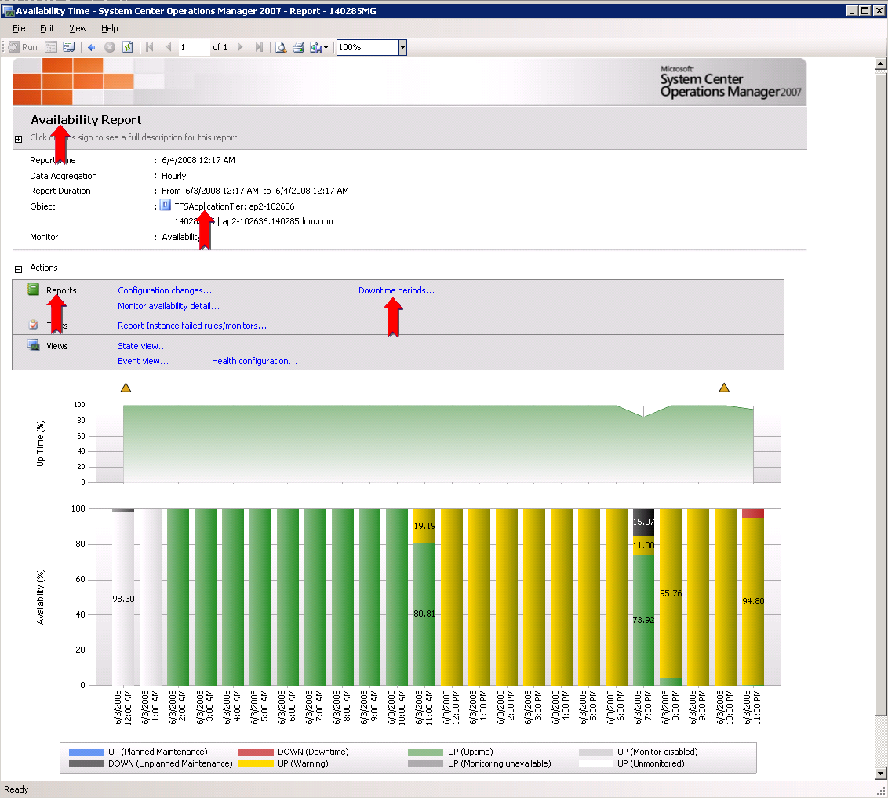

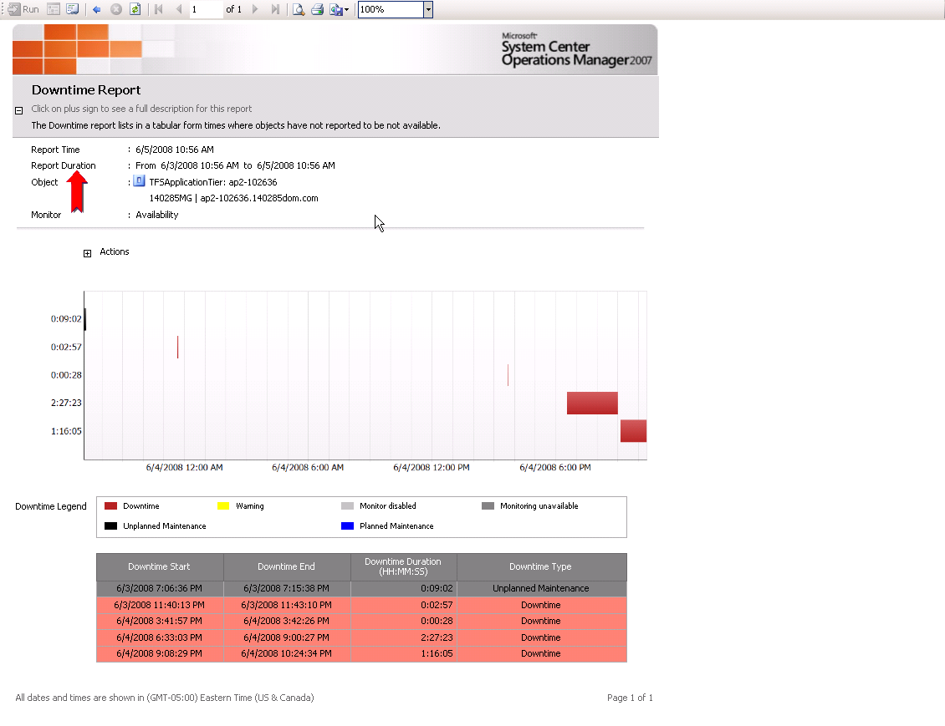

Figure: Downtime periods

The following is an example of an Alert Report

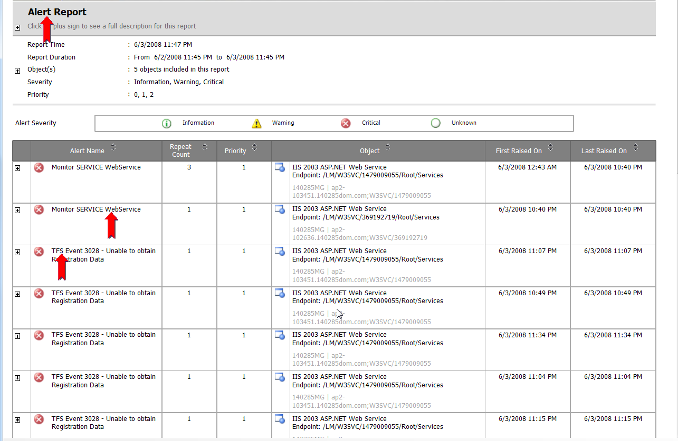

Health – Availability Report

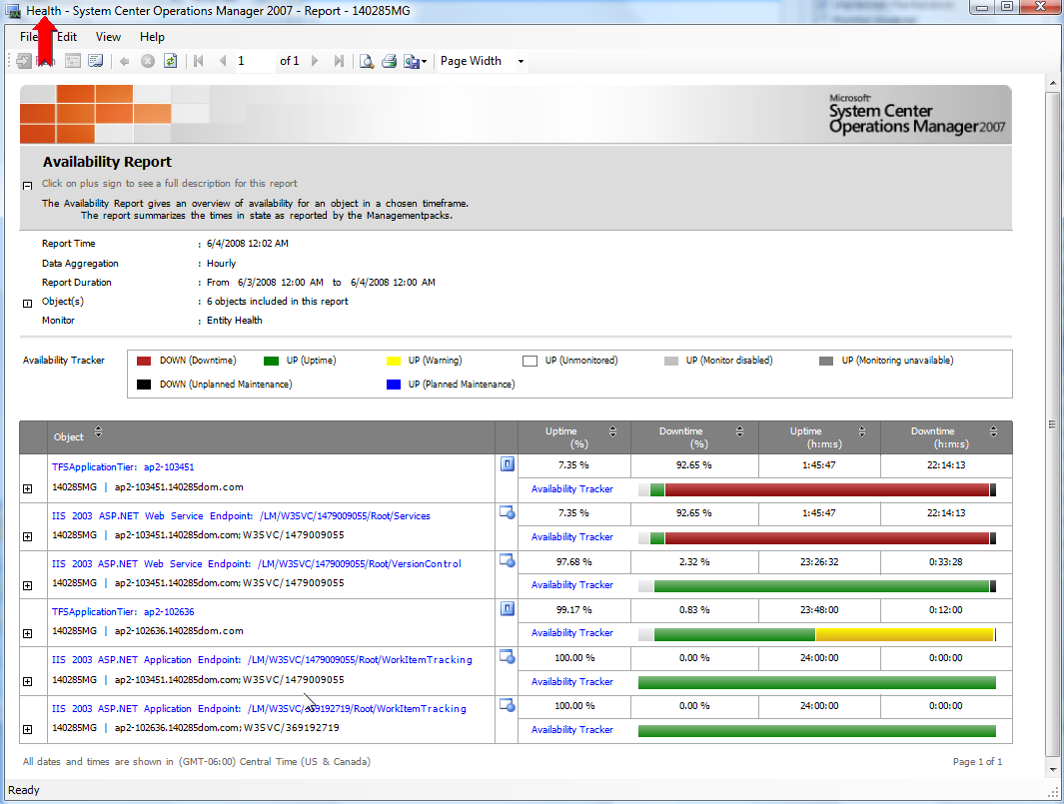

## Appendix A – Installation on System Center Operations Manager 2007 SP1

Please note that the installation steps for System Center Operations Manager 2012 are nearly identical to System Center Operation Manager 2007 R2. Please use the instructions in Appendix B for installation on SCOM 2012.

### Pre-Requisites

For the TFS MP to be deployed and used the following prerequisites must be met.

System Center Operations Manager 2007 infrastructure must be in place. This means Operations Manager Root Management Server (RMS) must be installed in addition to Agents which must be deployed on each of the servers that need to be monitored. Despite Operations Manager support for agent-less monitoring, it is recommended to have an agent on each managed node. It is also advised to have an Operator Console for doing administrative tasks.

The Team Foundation Server 2010 Management Pack doesn’t require any additional Management Packs that are not part of the standard Systems Center Operations Manager installation.

### Steps to Install the Management Pack

#### Create a Monitoring Account within Team Foundation Server

Prior to installing the MP, a “Run As Account” should be created within TFS which has privileges to access Team Foundation Server. This must be a TFS account that is a member of the *[Team Foundation]\Team Foundation Administrators* group to be able to properly discover and monitor the TFS configuration. It is recommended to create a special account for this in Active Directory and assign it to the required groups within Team Foundation Server. It is not recommended to use an existing Administrator account.

#### Creating a “Run As Account”

Go to the System Center Operations Manager Operator Console and open the Administration pane. Expand the Security Node, and then select “Run As Accounts”.  Right Click “Run As Accounts” and choose “Create Run As Account” to launch the wizard. This must be a TFS account that is a member of the *[Team Foundation]\Team Foundation Administrators* group to be able to properly discover and monitor the TFS configuration. The steps to create a “Run As Account” are shown below.

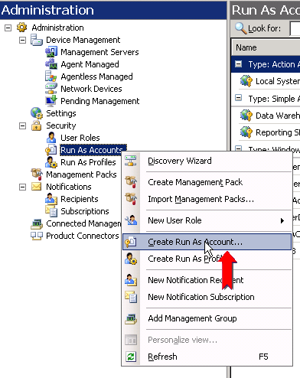

Select “Create Run As Account” and follow the steps in the wizard to create the “Run as Account”.

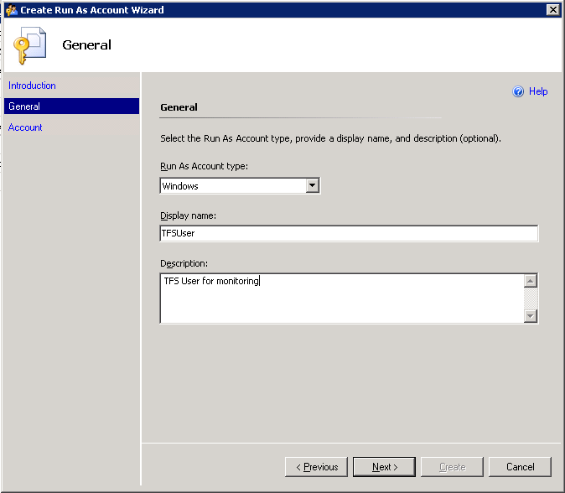

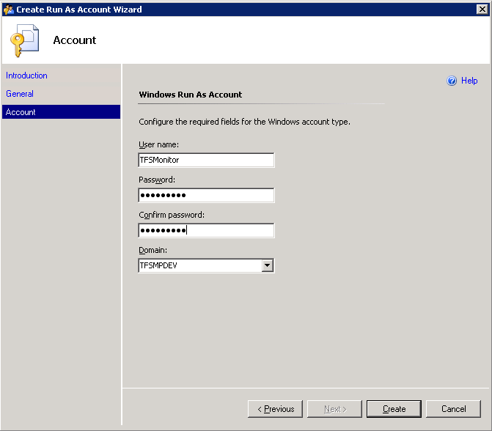

At the end of creating an account, you should see the new account in the “Run As Account” pane of the operator console as shown below.

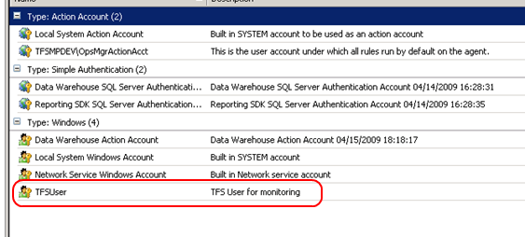

### Installing the Team Foundation Server MP

The next step is to install the MP. The install steps are very simple. This can be done by copying the sealed Team Foundation Server MP into a known location and importing the Team Foundation Server 2010 MP from that location via the “Import Management Packs” option in the Management Console. If there are any other missing dependent references, they must be imported before Team Foundation Server MP. You will be prompted for any missing dependencies and be given a chance to import them before the import of the Team Foundation 2010 MP will continue.

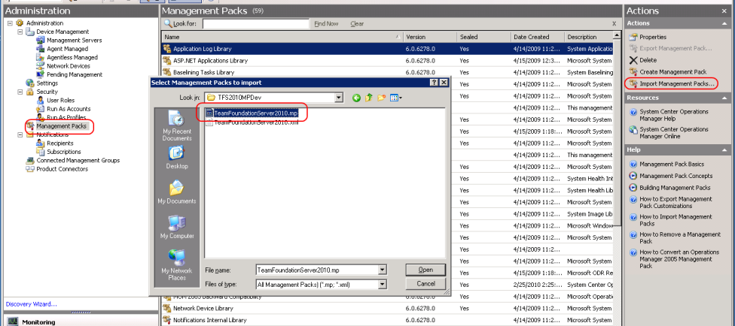

#### Associate the “Run As Account” to the “TFS 2010 User Profile”

Once the MP has been imported, the next step is to create the association between the “Run As Account” created earlier with the “TFS 2010 User Profile” in the MP. The steps to do this are shown below.

Go to the Administration Pane in the Operations Console and Right Click on the “Run As Profiles” node. You should see the TFS 2010 User Profile in the middle pane as shown below. If it does not appear, Right Click on *Run As Profiles* and hit “Refresh”.

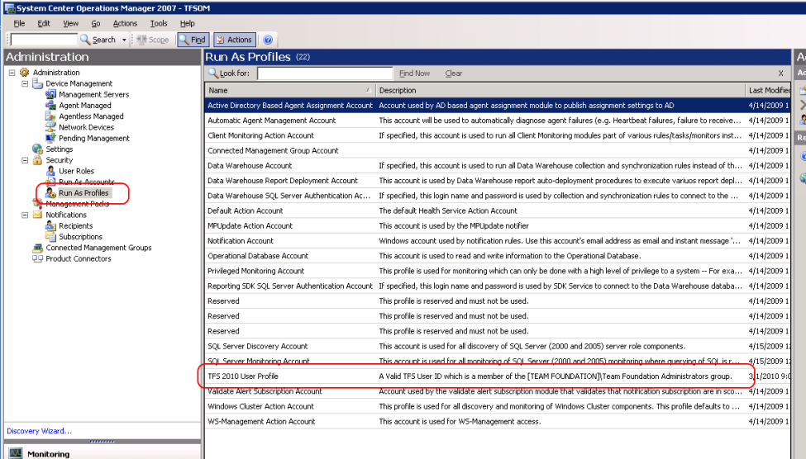

Double click the “TFS 2010 User Profile” once it is visible. Add the machines on which you want this association to be exercised. This should be all the Team Foundation Server application tier systems, proxy systems, and build systems (if you are monitoring the proxy and build systems within SCOM). You can determine which hosts are Team Foundation Server application tier hosts by looking in the Monitoring pane of the Ops console and opening up the “TFServer Application Tiers” folder. The Application Tier Servers should already be discovered. If the management pack was recently imported it may take a few minutes for this list to be populated. Be sure that the Application Tier servers are already discovered and agent monitored within Operations Manager. If you know the names of the Application Tier servers you can proceed without waiting. Only the basic information of Application Tier servers will be discovered until the Run As account is set up for each Application Tier Server.

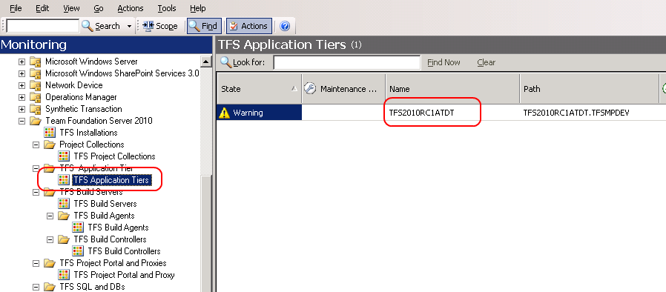

Make the association for those Team Foundation Server application tier hosts as shown below. Be sure to select “TFSUser” from the ***Run As Account***drop down list.

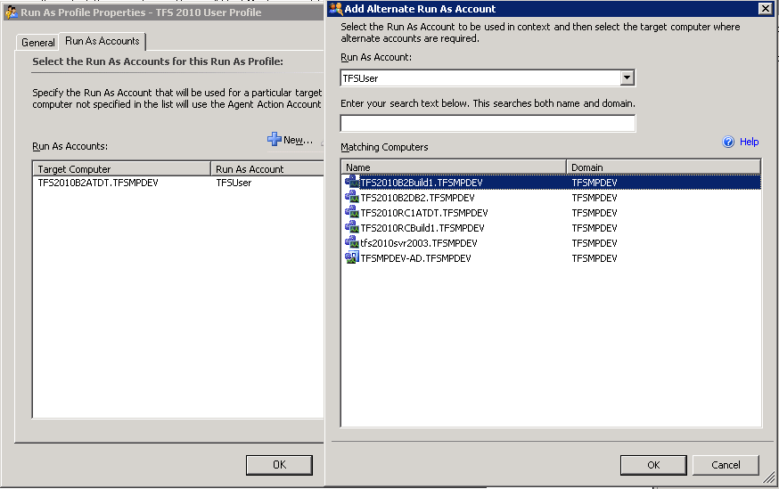

### Allow the Application Tier Servers Permissions in Operations Manager.

In order for the discovery of the entire installation to succeed, permissions must be given to the Application Tier servers to create objects on the behalf of other servers. First make sure that all the servers that are part of your TFS2010 installation have been discovered within Operations Manager. Once all the servers have been configured as managed assets within Operations manager, you must allow permissions to the Application Tier servers. To perform this step, go to the Administration view within the Management Console, and select the “Agent Managed” option. A list of servers that have been discovered and are under management is displayed.

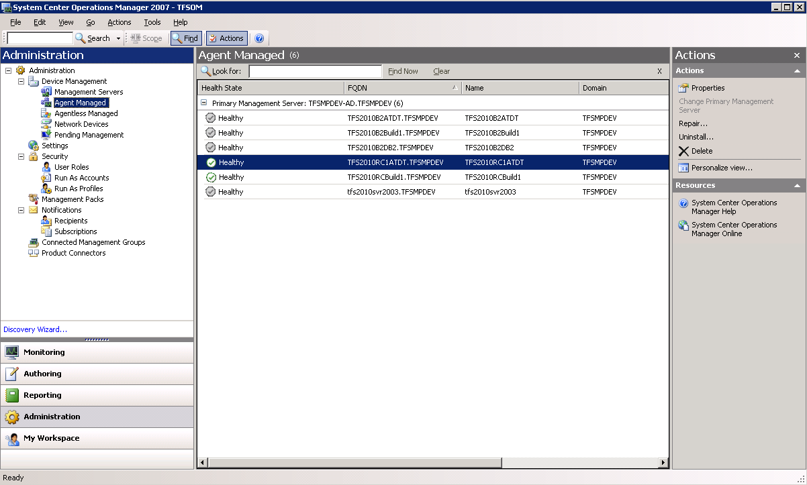

Right-click on each server in the Agent Managed view that has the TFS2010 Application tier installed and select the *Properties* entry from the right-click context menu. Within the agent properties dialog, select the “Security” tab and ensure that the check box for “Allow this agent to act as a proxy and discover managed objects on other computers” is selected.

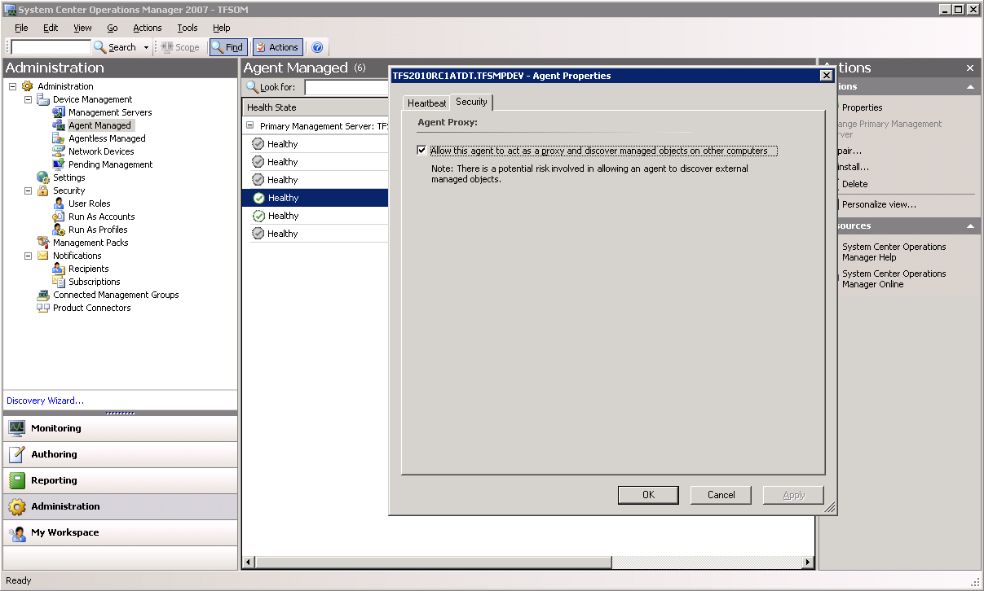

### Non-Default Port Configuration and SSL Only Bindings

There are two conditions that the discovery cannot detect through the TFS APIs. This is the installation of the TFS web services to a non-default port (not port 8080), and the use of SSL (HTTPS) only bindings for accessing TFS. If either of these is present in your installation it will be necessary to modify the management pack with overrides to allow the discovery to complete successfully. This will need to be completed once the management pack has been installed and configured as detailed above and the initial Application Tier (AT) servers have been discovered within your installation. This can be verified by checking the Monitoring tab and check under “TFS Application Tier Servers” for the presence of your AT tier servers. Once these AT Tier server(s) are found then configure the overrides using the steps as follows:

In the Operations Manager Console, select the Authoring tab and select “Object Discoveries” in the Authoring panel under “Management Pack Objects”.

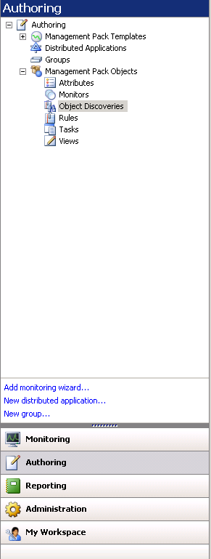

The console should now display all the object discovers for all the management packs installed in the main panel.

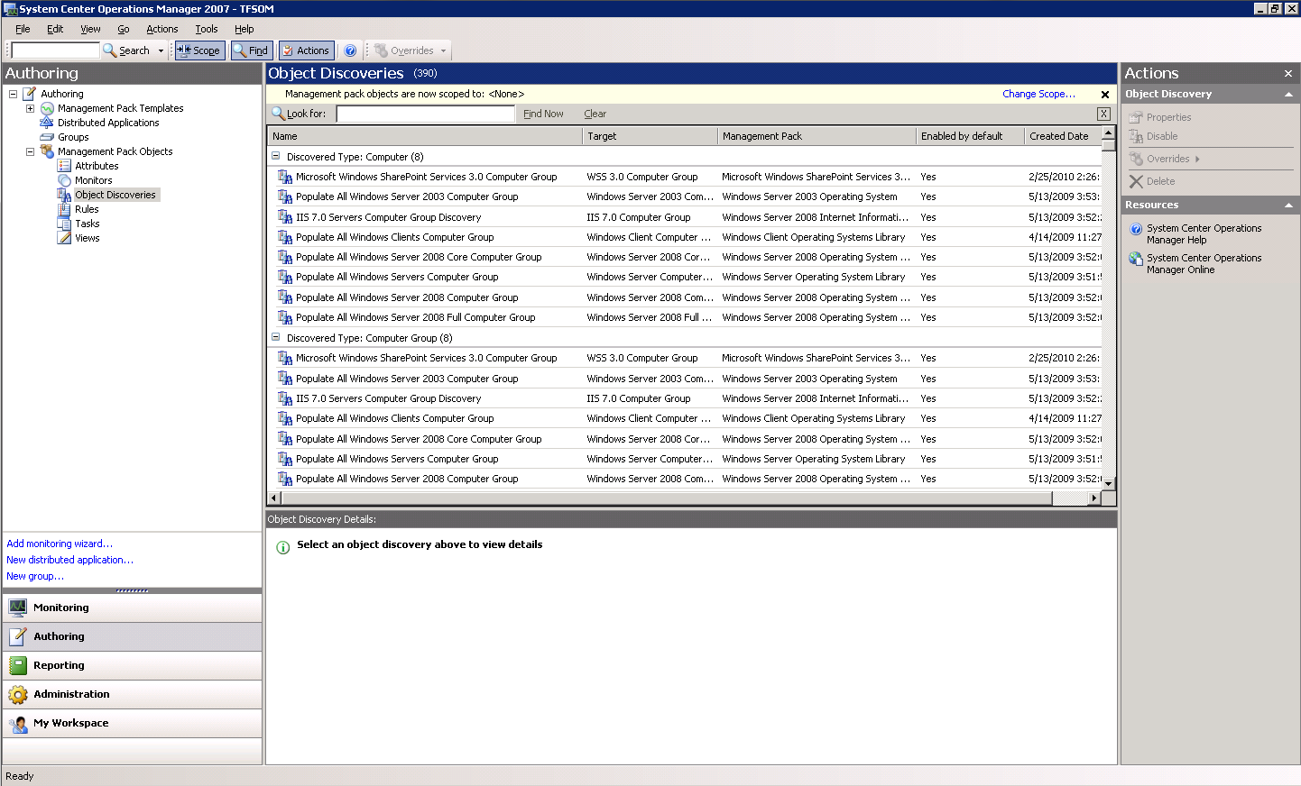

Find the entry for the “TFS Application Tier (AT) Server”. You may want to filter down the list by using the “Look for:” capability of the console and filter by “TFS”.

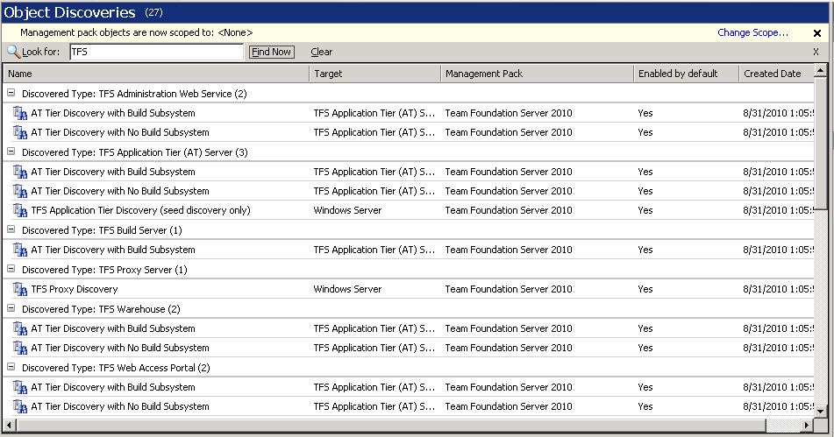

If you will NOT be monitoring the build servers within SCOM, then right click and use the context menu to disable the “AT Tier Discovery with Build Subsystem” as it will not be needed. If you ARE monitoring the build systems within SCOM, then right click and use the context menu to disable the “AT Tier Discovery with No Build Subsystem”.

Now right click on the discovery that is still enabled and select **Overrides -> Override the Object Discovery -> For a specific object of type: TFS Application Tier (AT) Server**.

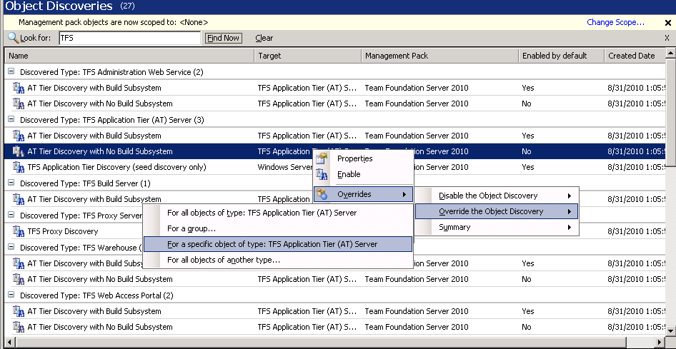

A dialog will appear and you will need to select a TFS Application Tier object that has been discovered.

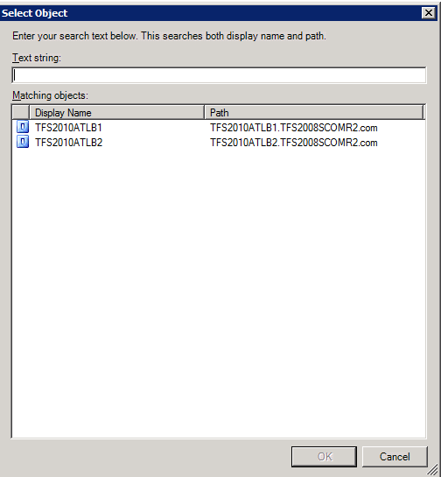

Select the appropriate server and another dialog will appear to allow you to enter the override values.

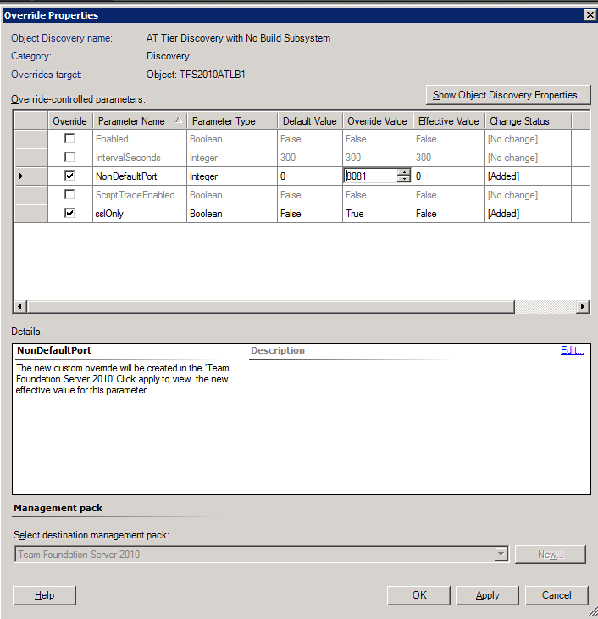

If your installation has a non-default port, select the “NonDefaultPort” checkbox and then enter the port number you have TFS configured for in the Override Value entry.

If you have set up TFS to only allow SSL (HTTPS) bindings, then select the “sslOnly” checkbox and set the override value to True.

Press Apply to set the values and at this time check to make sure that the proper values are shown in the Effective Value column. Press OK to save the overrides.

Repeat this for each AT tier server that you have in your TFS installation(s). After this is complete you can return to the Monitoring screen of the Operations Manager Console and wait for the discovery to complete. If after 20 minutes or more the discovery has not completed then check the troubleshooting section of this guide for further information on how to troubleshoot the issue.

### View of the Team Foundation Server MP Objects in the Operator Console.

After finishing the above mentioned steps, you should be able to see the MP objects in the Operator Console. Go to the Operator Console and click on the Monitoring pane.

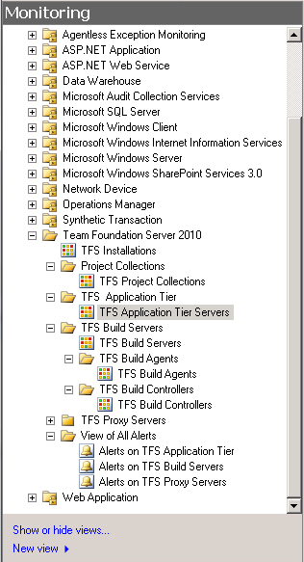

In the details pane, in the middle of the Operator Console, you can see the state views of the various Team Foundation Server Objects by navigating and clicking on them in the left pane. One such state view for the overall top node of the “application tier” is shown below. The figure below shows examples of states for monitored Team Foundation Servers.

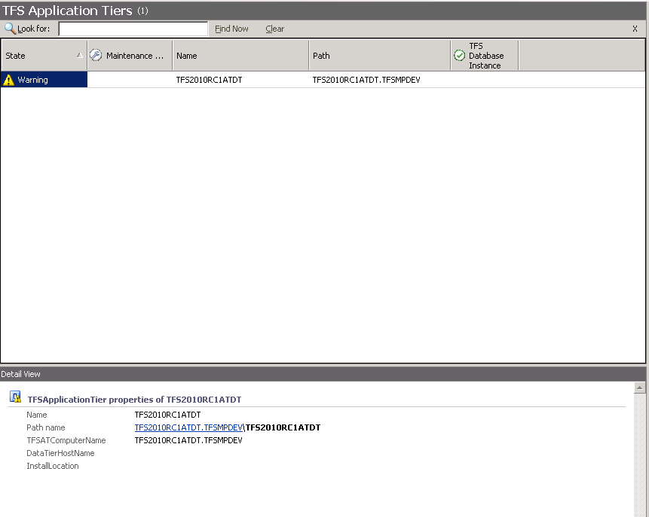

At this point, you are ready to start monitoring Team Foundation Servers in your network.

## Appendix B – Installation on System Center Operations Manager 2007 R2

Please note that the installation steps for System Center Operations Manager 2012 are nearly identical to System Center Operation Manager 2007 R2. Please use the instructions below for installation on SCOM 2012.

### Pre-Requisites

For the TFS MP to be deployed and used the following prerequisites must be met.

System Center Operations Manager 2007 infrastructure must be in place. This means Operations Manager Root Management Server (RMS) must be installed in addition to Agents which must be deployed on each of the servers that need to be monitored. Despite Operations Manager support for agent-less monitoring, it is recommended to have an agent on each managed node. It is also advised to have an Operator Console for doing administrative tasks.

The Team Foundation Server 2010 Management Pack doesn’t require any additional Management Packs that are not part of the standard Systems Center Operations Manager installation.

### Steps to Install the Management Pack

#### Create a Monitoring Account within Team Foundation Server

Prior to installing the MP, a “Run As Account” should be created which has privileges to access Team Foundation Server. This must be a TFS account that is a member of the *[Team Foundation]\Team Foundation Administrators* group to be able to properly discover and monitor the TFS configuration. It is recommended to create a special account for this in Active Directory and assign it to the required groups within Team Foundation Server. It is not recommended to use an existing Administrator account.

#### Creating a “Run As Account”

Now go to the System Center Operator Console and open the Administration pane. Expand the Security Node, and then select “Run As Accounts”.  Right Click “Run As Accounts” and choose “Create Run As Account” to launch the wizard. This must be a TFS account that is a member of the *[Team Foundation]\Team Foundation Administrators* group to be able to properly discover and monitor the TFS configuration. The steps to create a “Run As Account” are shown below.

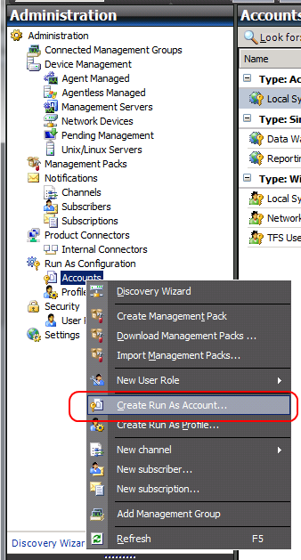

Select “Create Run As Account” and follow the steps in the wizard to create the “Run as Account”.

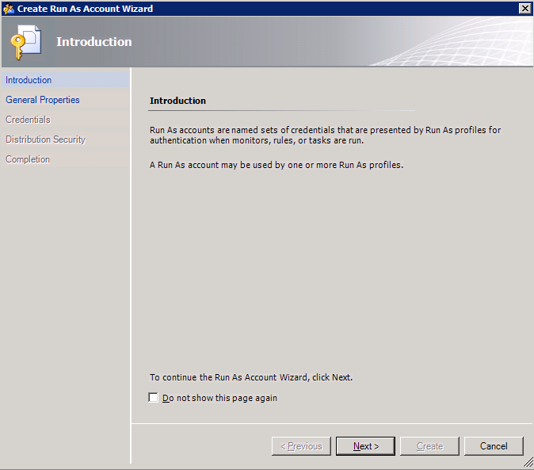

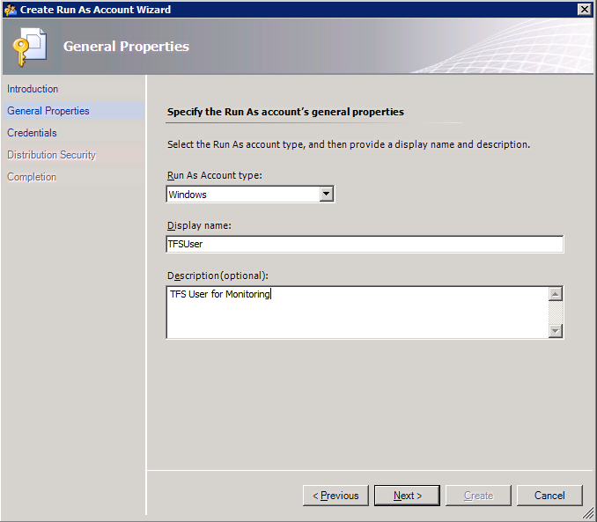

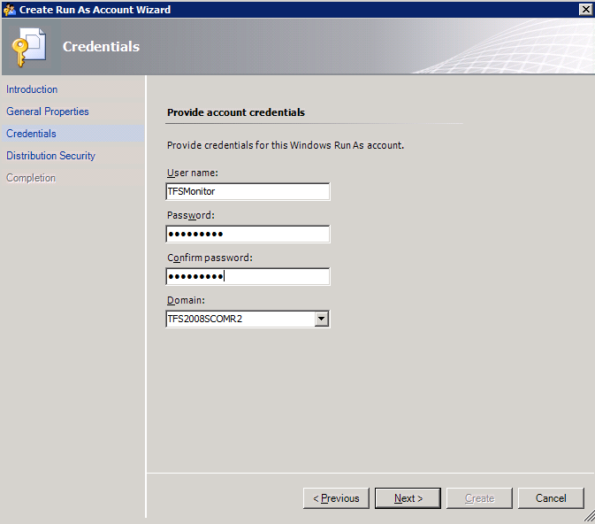

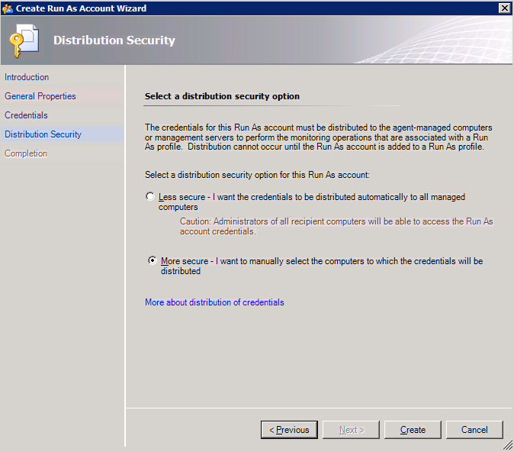

At the end of creating an account, you should see the new account in the “Run As Account” pane of the operator console as shown below.

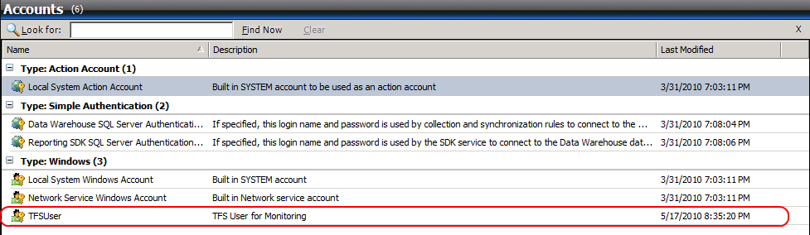

### Installing the Team Foundation Server MP.

The next step is to install the MP. The install steps are very simple. This can be done by copying the sealed Team Foundation Server MP into a known location and importing the Team Foundation Server 2010 MP from that location via the “Import Management Packs” option in the Management Console. If there are any other missing dependent references, they must be imported before Team Foundation Server MP. You will be prompted for any missing dependencies and be given a chance to import them before the import of the Team Foundation 2010 MP will continue.

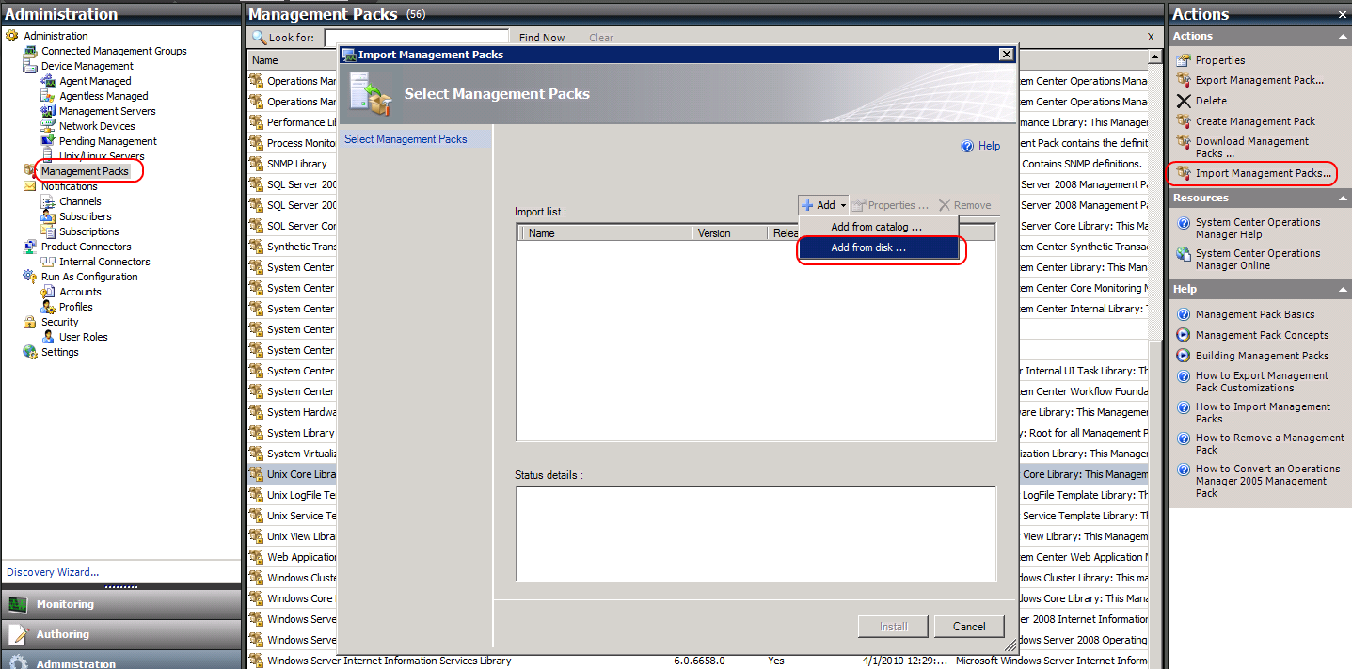



### Associate the “Run As Account” to the “TFS 2010 User Profile”

Once the MP has been imported, the next step is to create the association between the “Run As Account” created earlier with the “TFS 2010 User Profile” in the MP. The steps to do this are shown below.

Go to the Administration Pane in the Ops Console and Right Click on the “Run As Profiles” node. You should see the TFS 2010 User Profile in the middle pane as shown below. If it does not appear, Right Click on *Run As Profiles* and hit “Refresh”.

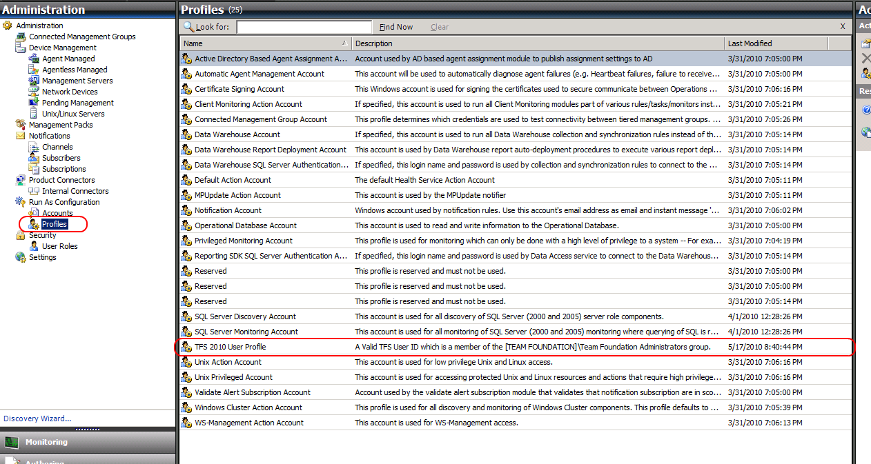

Double click the “TFS 2010 User Profile” Once it is visible. Add the machines on which you want this association to be exercised. This should be all the Team Foundation Server application tier systems. You can determine which hosts are Team Foundation Server application tier hosts by looking in the Monitoring pane of the Ops console and opening up the “TFServer Application Tiers” folder. The Application Tier Servers should already be discovered. If the management pack was recently imported it may take a few minutes for this list to be populated. Be sure that the Application Tier servers are already discovered and agent monitored within Operations Manager. If you know the names of the Application Tier servers you can proceed without waiting. Only the basic information of Application Tier servers will be discovered until the Run As account is set up for each Application Tier Server.

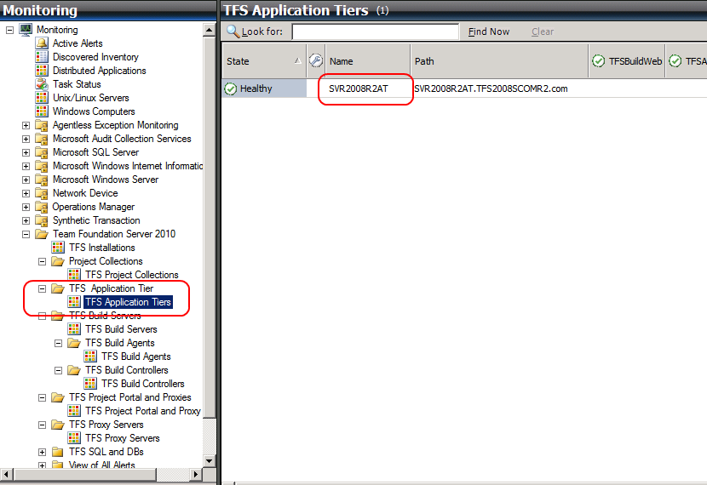

Make the association for those Team Foundation Server application tier hosts as shown below. Be sure to select “TFSUser” from the *Run As Account* drop down list.

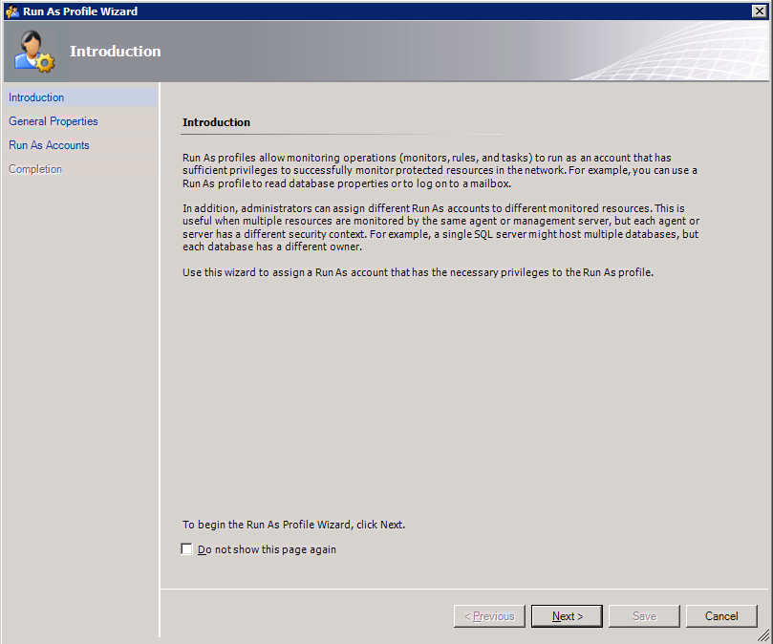

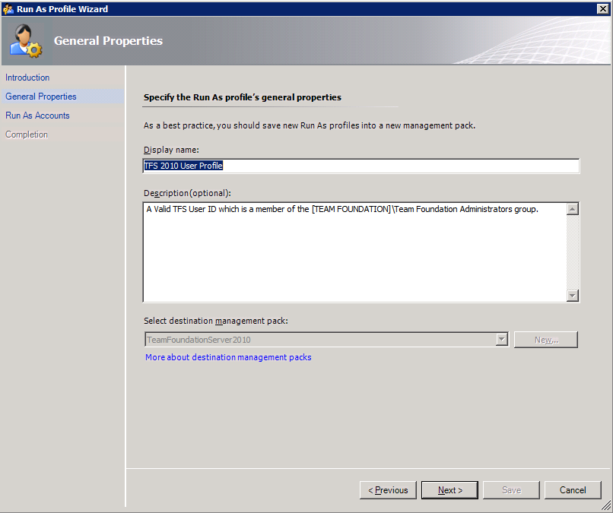

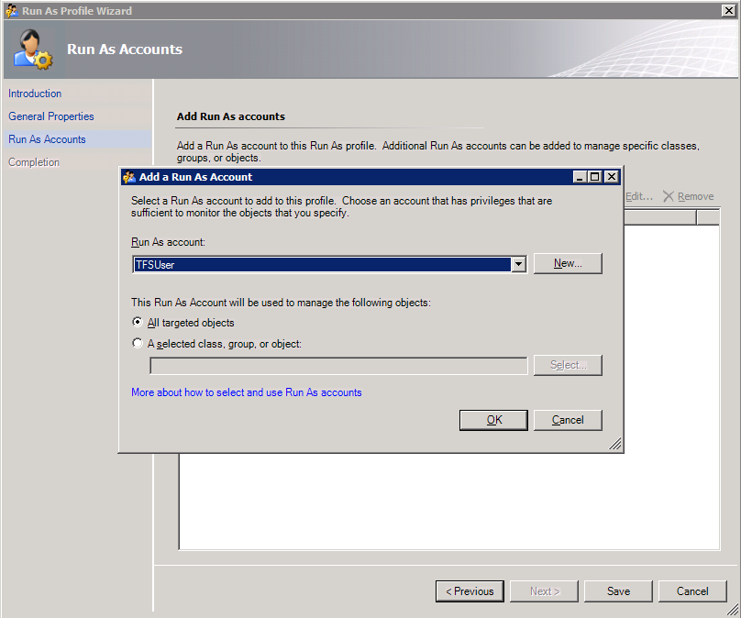

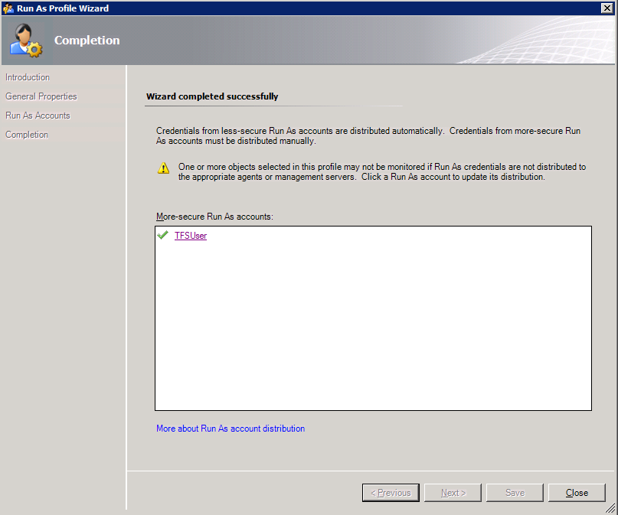

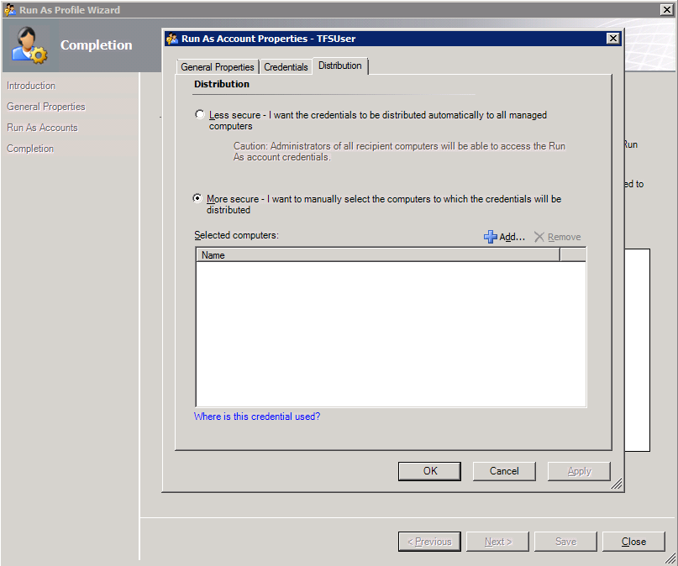

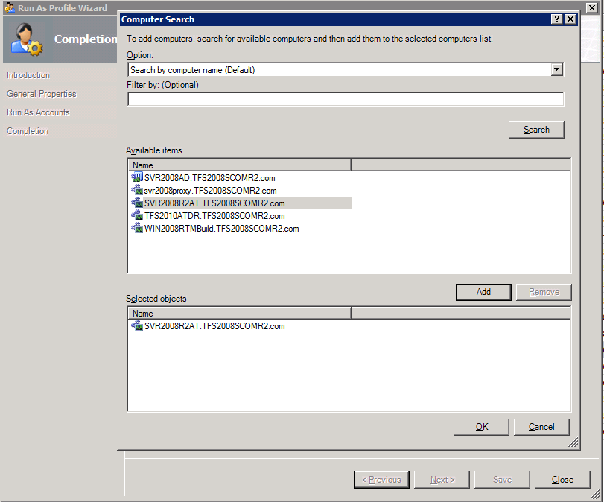

### Allow the Application Tier Servers Permissions in Operations Manager.

In order for the discovery of the entire installation to succeed, permissions must be given to the Application Tier servers to create objects on the behalf of other servers. First make sure that all the servers that are part of your TFS2010 installation have been discovered within Operations Manager. This includes AT Tier servers, Build Servers, and Proxy Servers. Note: it is not required to manage the Build Servers with the TFS Management Pack, but if you plan to monitor the Build Servers they must first be set up as managed computers within SCOM before the discovery can add them. Once all the servers have been configured as managed assets within Operations manager, you must allow permissions to the Application Tier servers. To perform this step, go to the Administration view within the Management Console, and select the “Agent Managed” option. A list of servers that have been discovered and are under management is displayed.

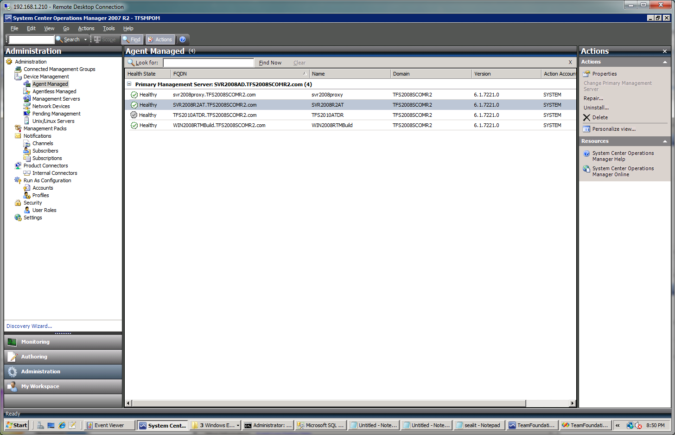

Right-click on each server in the Agent Managed view that has a TFS2010 Application tier installed and select the *Properties* entry from the right-click context menu. Within the agent properties dialog, select the “Security” tab and ensure that the check box for “Allow this agent to act as a proxy and discover managed objects on other computers” is selected.

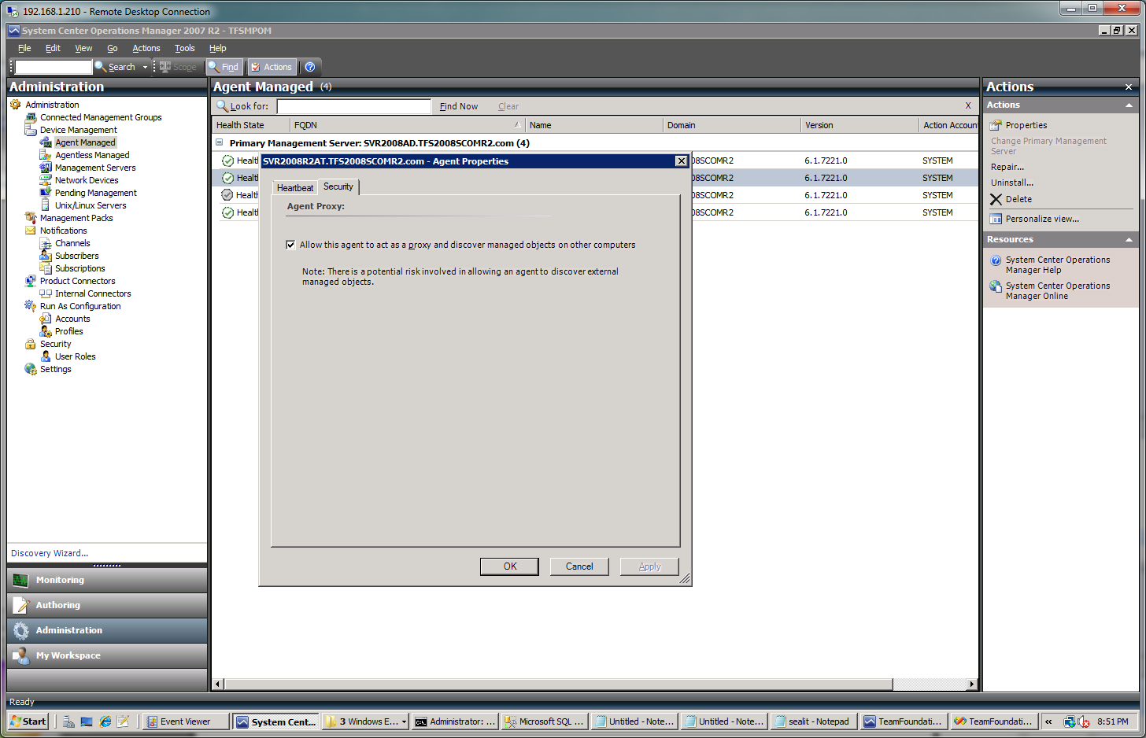

### Non-Default Port Configuration and SSL Only Bindings

There are two conditions that the discovery cannot detect through the TFS APIs. This is the installation of the TFS web services to a non-default port (not port 8080), and the use of SSL (HTTPS) only bindings for accessing TFS. If either of these is present in your installation it will be necessary to modify the management pack with overrides to allow the discovery to complete successfully. This will need to be completed once the management pack has been installed and configured as detailed above and the initial Application Tier (AT) servers have been discovered within your installation. This can be verified by checking the Monitoring tab and check under “TFS Application Tier Servers” for the presence of your AT tier servers. Once these AT Tier server(s) are found then configure the overrides using the steps as follows:

In the Operations Manager Console, select the Authoring tab and select “Object Discoveries” in the Authoring panel under “Management Pack Objects”.

The console should now display all the object discoveries for all the management packs installed in the main panel.

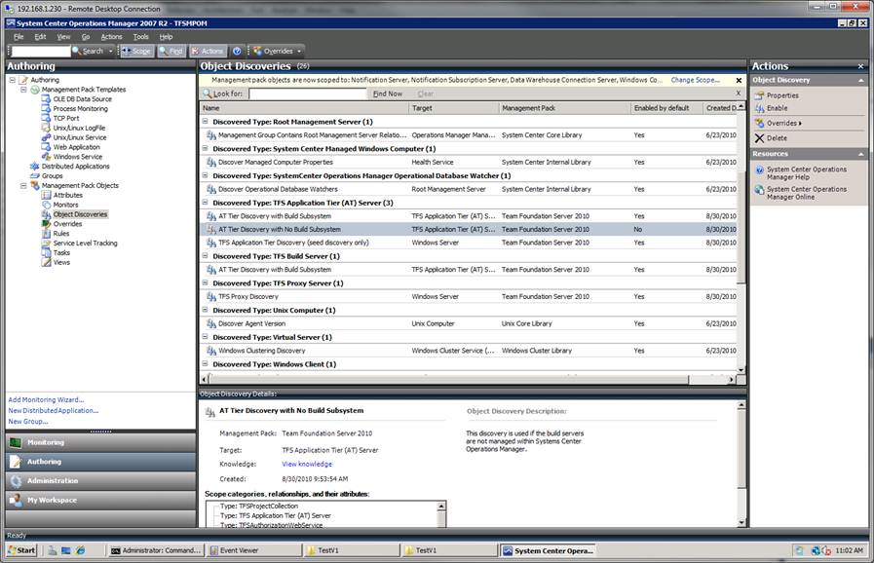

Find the entry for the “TFS Application Tier (AT) Server”. You may want to filter down the list by using the “Look for:” capability of the console and filter by “TFS”.

If you will NOT be monitoring the build servers within SCOM, then right click and use the context menu to disable the “AT Tier Discovery with Build Subsystem” as it will not be needed. If you ARE monitoring the build systems within SCOM, then right click and use the context menu to disable the “AT Tier Discovery with No Build Subsystem”.

Now right click on the discovery that is still enabled and select **Overrides -> Override the Object Discovery -> For a specific object of type: TFS Application Tier (AT) Server**.

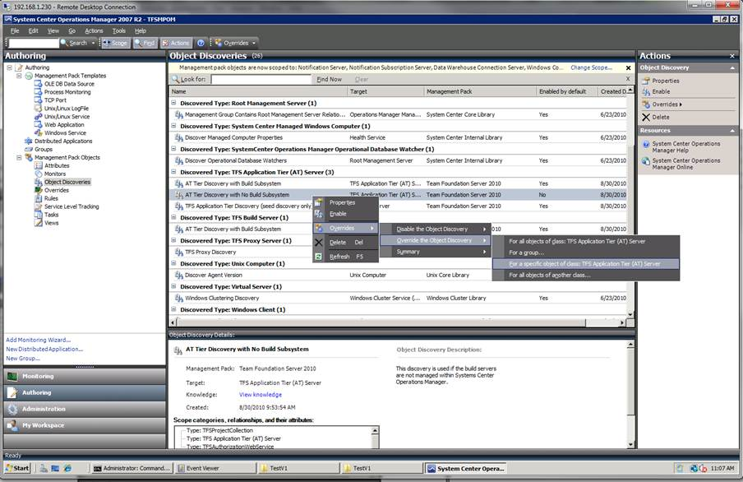

A dialog will appear and you will need to select a TFS Application Tier object that has been discovered.



Select the appropriate server and another dialog will appear to allow you to enter the override values.



If your installation has a non-default port, select the “NonDefaultPort” checkbox and then enter the port number you have TFS configured for in the Override Value entry.

If you have set up TFS to only allow SSL (HTTPS) bindings, then select the “sslOnly” checkbox and set the override value to True.

Press Apply to set the values and at this time check to make sure that the proper values are show in the Effective Value column. Press OK to save the overrides.

Repeat this for each AT tier server that you have in your TFS installation(s). After this is complete you can return to the Monitoring screen of the Operations Manager Console and wait for the discovery to complete. If after 20 minutes or more the discovery has not completed then check the troubleshooting section of this guide for further information on how to troubleshoot the issue.

### View of the Team Foundation Server MP Objects in the Operator Console

After finishing the above mentioned steps, you should be able to see the MP objects in the Operator Console. Go to the Operator Console and click on the Monitoring pane.

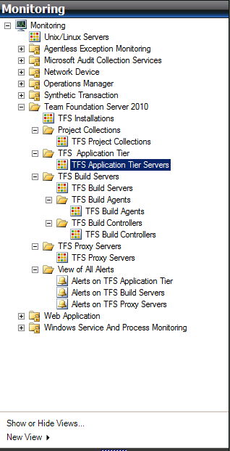

In the details pane, in the middle of the Operator Console, you can see the state views of the various Team Foundation Server Objects by navigating and clicking on them in the left pane. One such state view for the overall top node of the “application tier” is shown below. The figure below shows examples of states for monitored Team Foundation Servers.

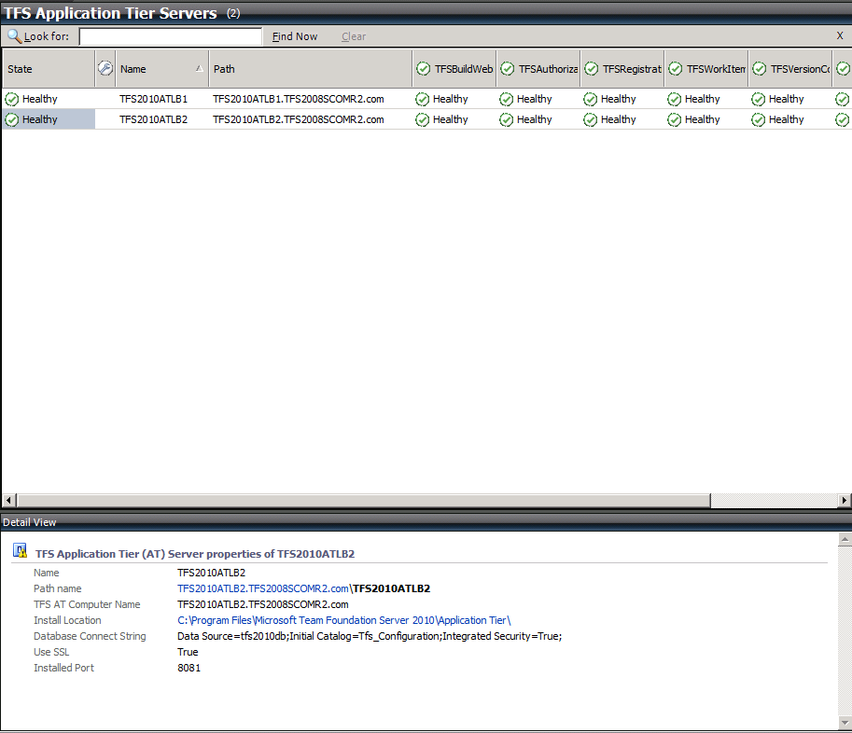

At this point, you are ready to start monitoring Team Foundation Servers in your network.

## Appendix C - Known Issues and Troubleshooting

### Troubleshooting Incomplete Discovery

The discovery of the TFS installation components is a two-step process. The initial discovery is triggered by registry keys that are set during the installation of the Team Foundation Server product. This will create the initial Application Tier object within the monitoring system, but is unable to complete the entire discovery of all the Application Tier properties or other TFS components such as Team Project Collections or Build Servers. At the end of the initial discovery the Management Console will show the basic Application Tier Servers:

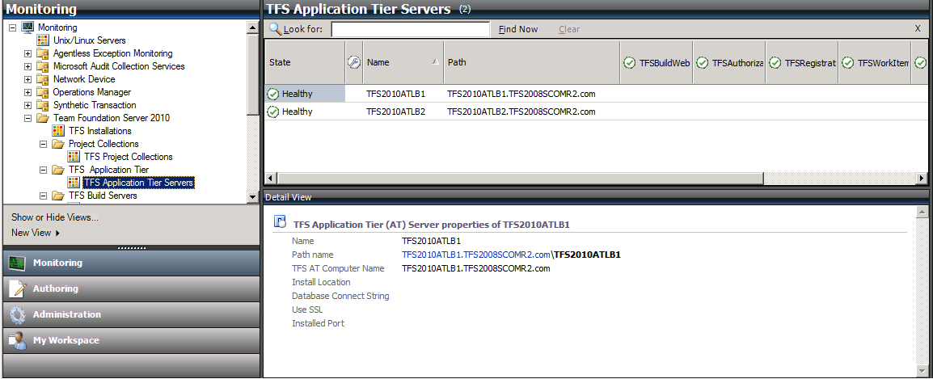

The other objects such as TFS Installations, TFS Project Collections, and Build components will not be found at this time. The secondary discovery should run after the initial objects are found and will populate these elements.

If the discovery doesn’t update after 20 minutes it may be necessary to check the discovery for errors. To do this check the Event Viewer on the application tier server looking for errors in the Operations Manager Log which can be found under the “Applications and Services Logs” entry:

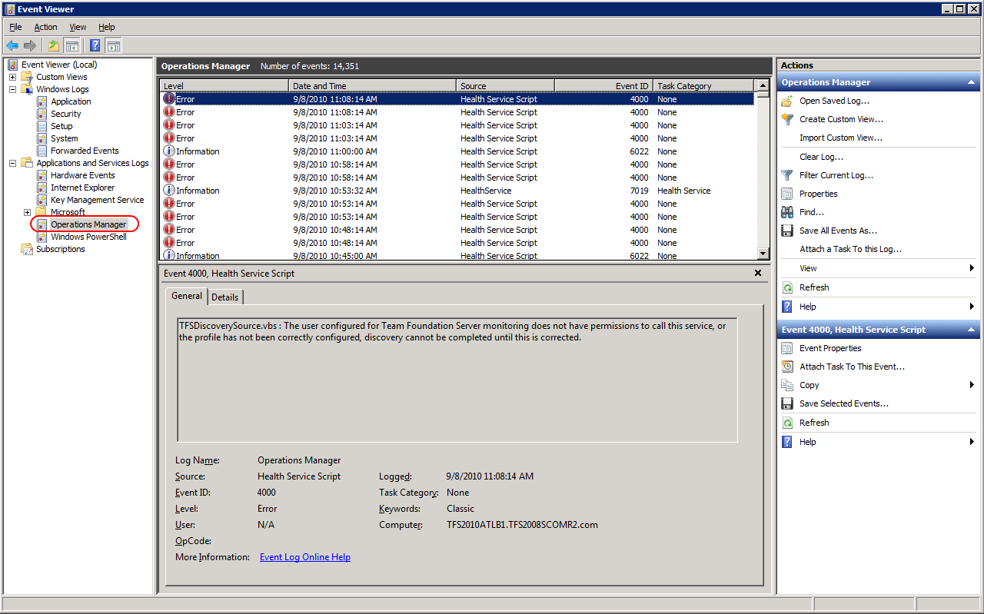

Check to see if an error with an Event ID of 4000 is present. This is the error written when the discovery script was unable to complete and signals an error. If this error entry is present there are three common issues that can cause it:

* The TFS 2010 User Profile was not assigned a run as account after the Management Pack was installed or upgraded. Check that you have a User Profile set up by checking the “TFS 2010 User Profile” in the Profiles view of the Administration view.

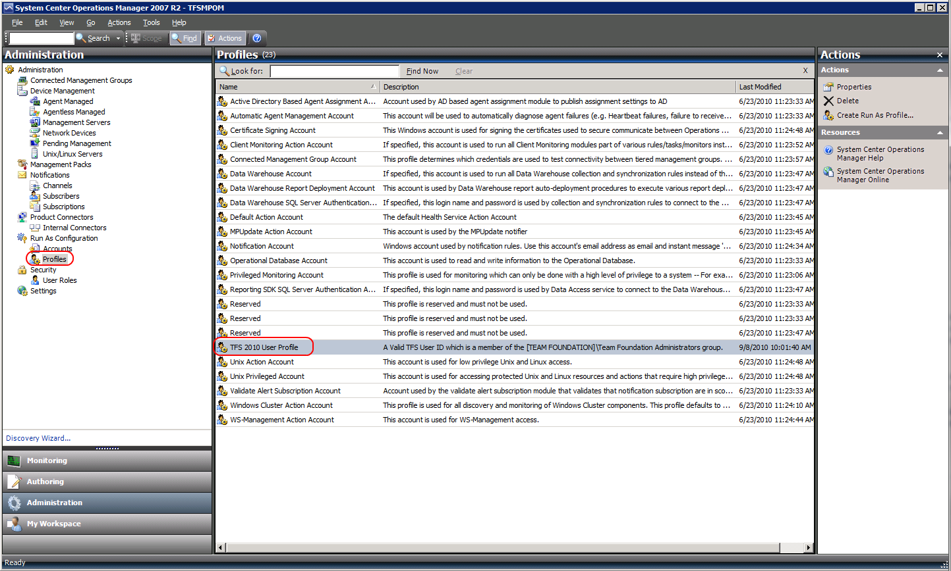

Ensure that you have assigned the TFS Monitoring account to the profile.

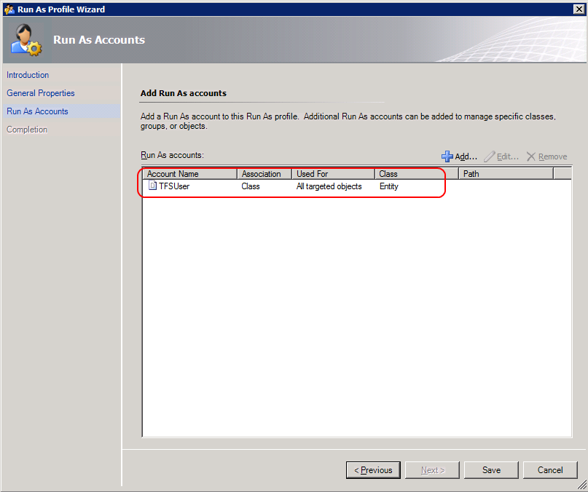

If the profile has not been assigned, follow the instructions in Appendix A or Appendix B to associate a run as account to the profile.

* TFS has been installed on non-default ports. The discovery cannot detect when TFS has been installed on an alternate port. If you are not using port 8080 you will need to add an override to allow the secondary discovery script to complete. See the instructions in Appendix A or Appendix B for instructions on how to enter an override for the installed port.
* TFS was installed with only SSL endpoints enabled. The discovery cannot detect if the IIS bindings are set up to support SSL (HTTPS) only. If you have configured the TFS installation for SSL only endpoints you will need to add an override to allow the secondary discovery script to complete. See the instructions in Appendix A or Appendix B for instructions on how to enter an override for the installed port.
* The Application Tier servers were not given permission to act as a proxy and create objects that are not located on their own server, see Appendix A or Appendix B for detailed instructions on how to set proxy permissions on the application tier servers.

## Appendix D – Installation and Use of the Team Foundation Server 2010 Best Practices Analyzer

A pair of Agent Task has been included in the Team Foundation Server 2010 Management Pack that can assist in the use of the TFS Best Practices Analyzer that is part of the Team Foundation Server Power Tools. The Best Practices Analyzer can interrogate a TFS installation and report configuration or operations problems. Due to the differences in the installation location of the Best Practices Analyzer on x86 and x64 systems, two tasks are included, one for 32 bit and one for 64 bit installations. Running the incorrect version for the operations system on the target application tier server will result in an error finding the analyzer tool. The Best Practice Analyzer does not support SSL only installations, so if you have TFS installed with only HTTPS bindings the Analyzer will not run correctly.

The latest version of the TFS Best Practices Analyzer can be found as part of the [Team Foundation Server Power Tools April 2010](http://visualstudiogallery.msdn.microsoft.com/en-us/3e8c9b68-6e39-4577-b9b7-78489b5cb1da) . If an updated version is released after the writing of this document you will find it at the [Microsoft Visual Studio 2010 Gallery](http://visualstudiogallery.msdn.microsoft.com/en-us/site/search?f%5B0%5D.Type=RootCategory&f%5B0%5D.Value=tools). After downloading the Power Tools, install the package using the default install on each Application Tier servers you want to run it on.

It is required that the user profile that executes the analyzer is a member of the local machine administrators group to allow the Analyzer to access all the required resources to perform its tasks. The Best Practices Analyzer Agent Task is configured in the Management Pack to run as the TFS Monitor user that was created for monitoring during the installation of the Management Pack. If you want to run the Best Practices Analyzer you will need to add this account to the local Administrators group of each of the servers that will be analyzed. See the TFS Best Practice Analyzer help file for detailed information on the prerequisites needed for proper operation of the Best Practice Analyzer.